

**University of Jordan**

**King Abdullah College of Information Technology**

**Systems Analysis and Design**

**Supervisor:** Dr. Hamad Alswalqah.

**Project subject**: Blood Bank Management System.

14/11/2020

|  |  |
| --- | --- |
| Name | Id |
| Shayma Al-Akhrass | 0187190 |
| Rawan Abu Snaineh | 0183927 |
| Bayan Daboubash | 0187096 |
| Lina Afaneh | 0183660 |
| Basel Abu Alaish | 0187604 |
| Oraib Al-Majali | 0187100 |

Table of Content:

1.0 Introduction ---------------------------------------------------------------------------------------------5

1.1 background -------------------------------------------------------------------------------------5

1.2 problem definition -----------------------------------------------------------------------------5

1.3 issues --------------------------------------------------------------------------------------------5

1.4 objectives ----------------------------------------------------------------------------------------6

1.5 requirements ------------------------------------------------------------------------------------6

1.6 constraints ---------------------------------------------------------------------------------------6

1.7 proposed solution ------------------------------------------------------------------------------7

1.8 local and global impact of the proposed solution ------------------------------------------7

1.9 schedule and outline ---------------------------------------------------------------------------7

2.0 Feasibility Study ----------------------------------------------------------------------------------------- 8

2.1 Technical Feasibility ----------------------------------------------------------------------------8

2.2 Operational Feasibility --------------------------------------------------------------------------8

2.3 Economic Feasibility ----------------------------------------------------------------------------8

2.4 Schedule Feasibility ----------------------------------------------------------------------------10

2.5 Legal Feasibility --------------------------------------------------------------------------------10

3.0 Human Information Requirements ---------------------------------------------------------------------11

3.1 Identify System Stakeholders and Requirements Sources ---------------------------------11

3.2 Requirements Elicitation Techniques ---------------------------------------------------------11

3.3 Functional Requirement Definition -----------------------------------------------------------13

3.4 Functional Requirement Specification --------------------------------------------------------14

3.5 Non-Functional Requirements -----------------------------------------------------------------14

3.6 Software and Hardware Requirements --------------------------------------------------------15

4.0 System Analysis -------------------------------------------------------------------------------------------17

4.1 Context Diagram ---------------------------------------------------------------------------------17

4.2 Data Flow Diagram ------------------------------------------------------------------------------18

4.3 Entity Relationship Diagram -------------------------------------------------------------------19

4.4 Data Dictionary ----------------------------------------------------------------------------------19

4.5 Structured Decision Analysis ------------------------------------------------------------------24

4.6 System Proposal ---------------------------------------------------------------------------------25

5.0 System Design ---------------------------------------------------------------------------------------------31

5.1 Architecture Design-------------------------------------------------------------------------------31

5.2 Graphical User Interface Design----------------------------------------------------------------32

5.3 Database Design-----------------------------------------------------------------------------------42

6.0 System Implementation -----------------------------------------------------------------------------------43

6.1 Graphical User Interface Implementation -----------------------------------------------------43

6.2 Database Implementation ------------------------------------------------------------------------52

7.0 Conclusion--------------------------------------------------------------------------------------------------56

8.0 References **--------------------------------------------------------------------------------------------------**56

9.0 Appendix ----------------------------------------------------------------------------------------------------56

List of tables:

1.1 Hardware and software costs -----------------------------------------------------------------------------------8

1.2 Employee Development Costs ---------------------------------------------------------------------------------9

1.3 Projected annual operating cost --------------------------------------------------------------------------------9

3.1 Nonfunctional requirements ----------------------------------------------------------------------------------14

3.2 Software requirements -----------------------------------------------------------------------------------------15

3.3 Hardware requirements ----------------------------------------------------------------------------------------16

4.1 Data flow 1 ------------------------------------------------------------------------------------------------------19

4.2 Data flow 2 ------------------------------------------------------------------------------------------------------20

4.3 Data flow 3 ------------------------------------------------------------------------------------------------------20

4.4 Data flow 4 ------------------------------------------------------------------------------------------------------20

4.5 Data flow 5 ---------- -------------------------------------------------------------------------------------------21

4.6 Data flow 6 ------------------------------------------------------------------------------------------------------21

4.7 Data store 1------------------------------------------------------------------------------------------------------21

4.8 Data store 2 -----------------------------------------------------------------------------------------------------22

4.9 Data store 3 ----------------------------------------------------------------------------------------------------- 22

4.10 Data store 4 --------------------------------------------------------------------------------------------------- 22

4.11 Data store 5 --------------------------------------------------------------------------------------------------- 23

4.12 Data store 6 --------------------------------------------------------------------------------------------------- 23

4.13 system architecture -------------------------------------------------------------------------------------------28

4.14 Software requirements (2) -----------------------------------------------------------------------------------28

4.15 Hardware requirements (2) ----------------------------------------------------------------------------------29

List of figures:

Figure 1.1: project timeline Gantt chart --------------------------------------------------------------------------7

Figure 3.1: donated blood -----------------------------------------------------------------------------------------12

Figure 3.2: number of donations ---------------------------------------------------------------------------------12

Figure 3.3: blood bank website -----------------------------------------------------------------------------------12

Figure 3.4: the help of the website -------------------------------------------------------------------------------13

Figure 4.1: Context Diagram --------------------------------------------------------------------------------------17

Figure 4.2: Data Flow Diagram -----------------------------------------------------------------------------------18

Figure 4.3: Entity Relationship Diagram ------------------------------------------------------------------------19

Figure 5.1: Architecture Design ----------------------------------------------------------------------------------31

Figure 5.2: Database Design --------------------------------------------------------------------------------------42

**1- Introduction**

* 1. **Background:**

A blood bank is a center where blood gathered as a result of blood donation is stored and preserved for later use in blood transfusion. The term "blood bank" refers to the place where blood is stored and collected. Our blood bank system is designed to organize the process of providing blood units for those in need through hospitals, while managing the already existing stock of blood units in hospitals and how it reaches patients.

**1.2 Problem definition:**

Hospitals need an easier and faster way to organize the blood donation process, how to deal with the donor and organize donation procedures.

**1.3 Issues:**

1.The records of the donor might not be kept safely and there might be missing of donor's records due to human error or disasters.

Weight: 7

2.If a donor makes a donation in a different hospital, no previous records can be traced except if the donor brings along the donation certificate.

Weight: 9

3.there are also problems in keeping track of the actual amount of each and every blood type in the blood bank.

Weight: 6

**1.4 Objectives:**

1.Provide this organization and make this process smooth is an urgent need.

2.Provide the required need in the blood bank and facilitate the process of obtaining blood the necessary cases as soon as possible.

3.To allow the probable recipients to search and match the volunteer donors and make requests for the blood.

4.To provide immediate storage and retrieval of data and information.

5. Provide a purpose for our target customer.

6. Delivering the best value to the customer business.

7. Delivering a reliable and trustworthy product.

**1.5 Requirements:**

- The system must be secure.

- The system must be desirable and easy to use.

- GUI should be clear and easy to use.

- The Database should be able to store and retrieve data in short time.

**1.6 Constraints:**

- Development costs must not exceed $10000.

- The initial Web site to donate blood must be ready by January 1.

**1.7 proposed solution:**

Founding a new website.

**1.8 local and global impact of the proposed solution:**

The local impact of our solution is to heal Jordanian people of blood loss and blood overflow and Making the blood donation process easier and faster. The Global impact is to produce a greater health system for all people.

**1.9 Schedule and Outline:**

The project will start in 15/11/2020 and end in 01/1/2020.

Gant chart:

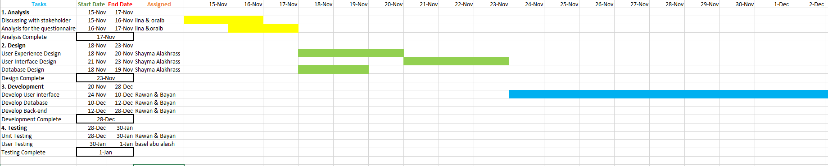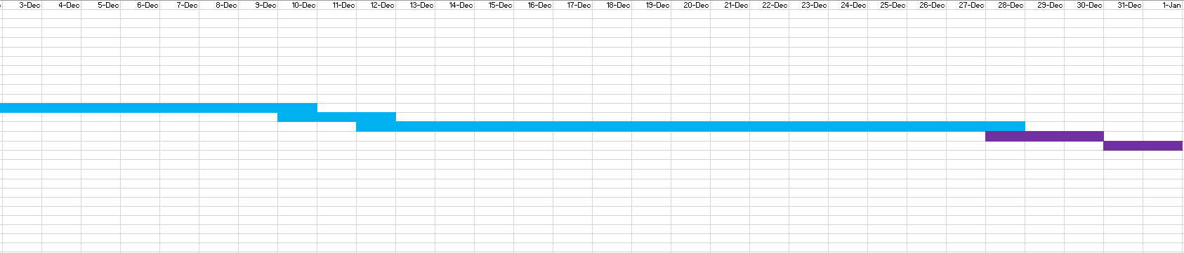

Figure 1.1: Project Timeline Gant Chart

**2- Feasibility Study**

**2.1 Technical feasibility:**

The system meets the specifications and we can hire programmers, testers, or others who may have different programming skills to accomplish the system in the best way.

**2.2 Operational feasibility:**

Our project does not have any problem in the operational side because:

- There is a Sufficient support for the User and the system is easy to maintain.

- The user benefits by saving his time and service from his place.

**2.3 Economic feasibility:**

Cost: hardware and software are available in the market at a low cos.

Table 1.1: Hardware and software Costs

|  |  |
| --- | --- |
| Hardware / software | Cost |
| Computer ($500) | $1000 |
| DBMS software ($300) | $300 |
| Server Software ($650) | $650 |

Total = 2050$

- Employee Development Costs :

Table 1.2: Employee Development Costs.

|  |  |
| --- | --- |
| Employee type | Total cost per hours |
| System Analysts(25h$20/h) | $500 |
| Programmer (18h $120/h) | $2160 |
| Database Specialist(14h$22/h) | $308 |
| GUI designer (13h $10/h) | $130 |
|  |  |

Total =$ 3098

- projected annual operating cost:

Table 1.3: projected annual operating cost.

|  |  |
| --- | --- |
| - | Cost |
| DBMS maintenance | $ 300 |
| Server maintenance | $ 600 |

Total = $900

**Benefits:**

1.This system reduces the number of working people, which increases profit.

2. Provides more accurate information about the people donating.

**2.4 Schedule Feasibility:**

The system needs 3 months to implement and a little delay is acceptable.

**2.5 Legal Feasibility:**

It is a study to know if the project is in compliance with the legal requirements and moral values, and this project is fully compatible with the requirements and values.

**3- Human Information Requirements**

**3.1 Identify System Stakeholders and Requirements Sources:**

System Stakeholders:

1. Doctor
2. Nurse
3. Analyst
4. Medical laboratory owners

**3.2 Requirements Elicitation Techniques:**

We used the following form to gather the needed data.

The sample was 50 persons

1. **Have you ever donated before?**
2. No
3. Yes
4. **How many times you donated blood in your life?**
5. Zero
6. Once
7. Twice
8. More than 2
9. **Would you be willing to use specialized blood bank website or use the traditional ways of donating?**
10. Yes
11. Maybe
12. I’d use the traditional ways
13. **Do you believe that an online website built for organizing blood donations would encourage people and make it easier for them to donate blood?**
14. Yes
15. No
16. Maybe

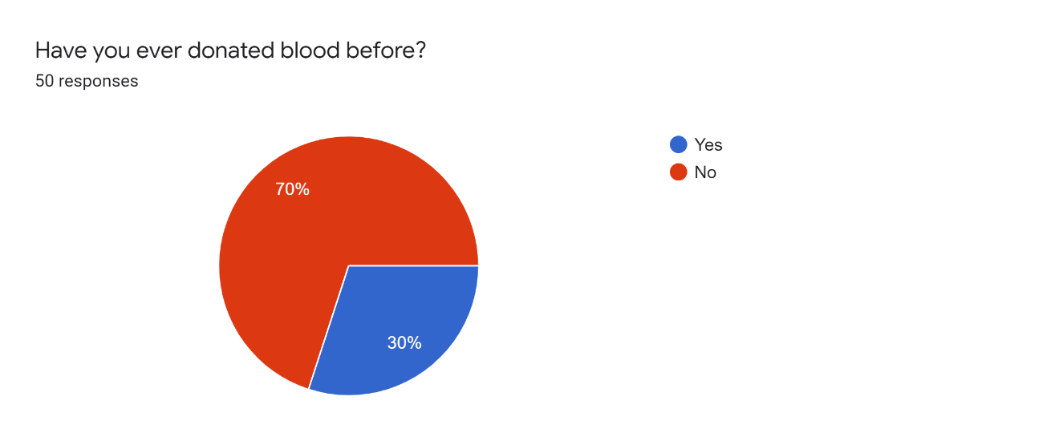

Figure 3.1: donated blood

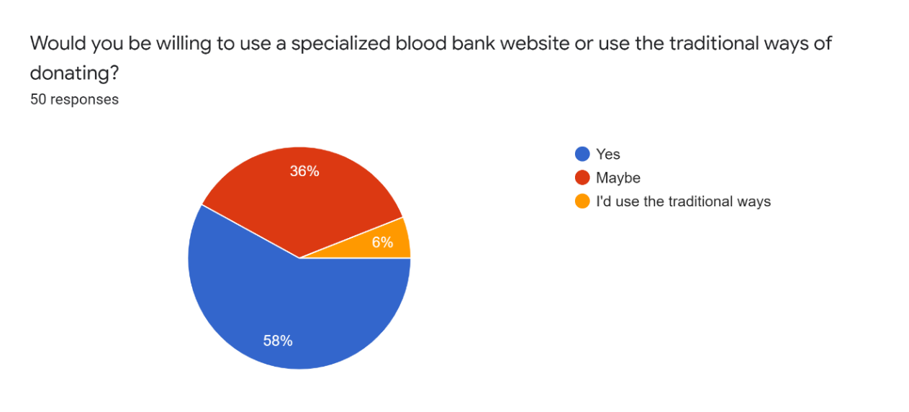Figure 3.2: number of donations

Figure 2: number of donation

Figure 3.3: blood bank website

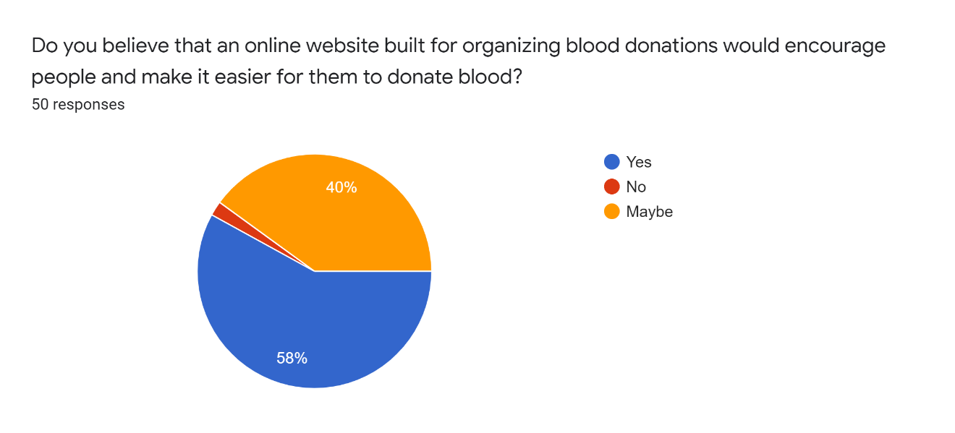

Figure 3.4: The help of the website

**3.3 Functional Requirement Definition:**

1. Blood bank management system is for helping people to donate blood but in a different way not like the traditional one, so they sign in to the system by their personal information like their name, blood type, weight and if they have any diseases the system will accept or reject their order depending on this information by sending a message to them.

2. This system for the people who need blood too, these people (patients) sign in to the system, they must apply personal information needed to provide the nurses or doctors in charge of the blood bank, after they are done with the application a massage is delivered to the patient informing him wither what they need is available or not to be acquired.

3. In this system you will see educational information about the blood donation methods it will help the person when he wants to donate blood (if the system accepts his order) to know how this method works.

Our blood bank management system is website to maintain day to day transactions in a blood bank. This website helps to register all the donors, blood collection details and blood issued details. Blood banks collect, store and provide blood. Typically, these banks collect blood from voluntary blood donors. The banks then sort blood by type, check blood to make sure it is free of disease and then store it for future use. The main mission of a blood bank is to provide life-saving blood to hospitals and other health care facilities.

**3.4 Functional Requirements Specification:**

* Login of Admin.
* Change the login password of admin.
* Blood Donor.
* Register the donor by himself.

**3.5 Non-Functional Requirements:**

Table 3.1: Nonfunctional requirements

|  |  |  |
| --- | --- | --- |
| ***Requirement*** | ***Title*** | ***Description*** |
| **1** | Security | Our website is fully secured by a username and password for donors. Each user in the system also has his password encrypted. |
| **2** | Performance | The website should run fast with no propagation, by code optimizations, in order to provide the best service. |
| **3** | Reliability | The system should be as reliable as possible, relying on availability in multiple points. |
| **4** | Ease of Use | Our website has a friendly interface that can be used by  different users with different skill levels. |
| **5** | Availability | Our website will be available for all users through a web application using web browsers, and this system will be available for users anywhere and anytime through the internet service, once they need it**.** |
| **6** | Flexibility | Application is easily customizable & scalable. Existing code is easy to modify, and new functionality can be easily added to extend the system’s capabilities. |

**3.6 Software and Hardware Requirements:**

1. Software requirements

Table 3.2: Software requirements

|  |  |
| --- | --- |
| **Software** | **Requirement** |
| **Operating system** | Windows 7 or higher operating systems, Linux Ubuntu 10.14 or higher,  Osx 10 or higher |
| **Browser** | Internet Explorer 8.0 (64-bit Internet Explorer 6.0+ is not supported), Firefox 3.0, Safari 4.1.2, and Google Chrome 11.0,  or higher versions. |

1. Hardware requirements

Table 3.3: Hardware requirements

|  |  |
| --- | --- |
| **Hardware** | **Requirement** |
| **CPU** | Intel Core i3-4200H 2.8 GHz or higher |
| **GPU** | Nvidia GTX GeForce GTX 760 or higher |
| **Memory**  **(RAM)** | 4 GB RAM or more |
| **Hard disk** | 30 GB Minimum |

**4- System Analysis**

#### **Introduction:**

Modeling Diagrams help to clarify and communicate ideas about the user requirements that the software system must support. As well as they identify and describe functional behavior and structure of the software.

#### **4.1 Context Diagram:**

Context Diagram is used to show the whole system how objects interact with main system.

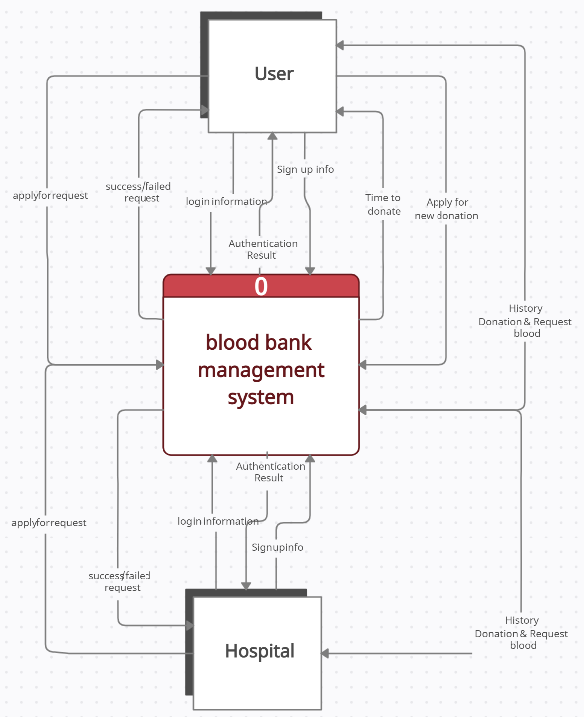

Figure1 4.1: Context Diagram

**4.2 Data flow diagram:**

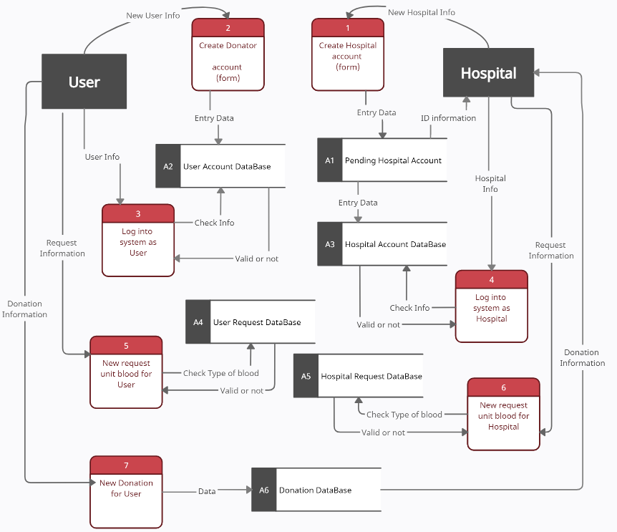

Figure2 4.3: Data Flow Diagram

**4.3 Entity relationship diagram:**

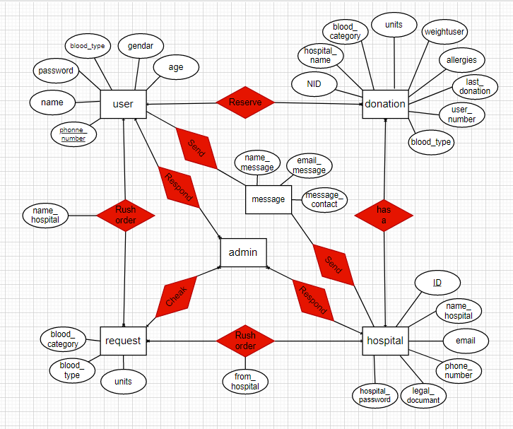

Figure3 4.4: Entity Relationship Diagram

#### **4.4 Data Dictionary Diagram**

Data Flow:

Table 4.1: Data flow 1

|  |  |
| --- | --- |
| ID | DF1 |
| Label | New hospital info |
| Name | Hospital account & sign up |
| Description | Contains hospital information and it’s used to create an account for the hospital and add it to the pending database. |
| Source | hospital External Entity |
| Destination | Process 1, Create hospital account |
| Type | Record Entering |
| Data Structure | Hospital information |
| Volume/Time | 1/life time |

Table 4.2: Data flow 2

|  |  |
| --- | --- |
| ID | DF2 |
| Label | New user info |
| Name | User account & sign up |
| Description | Contains user information and it’s used to create an account and add it to the database. |
| Source | User External Entity |
| Destination | Process 2, Create donor account |
| Type | Record Entering |
| Data Structure | User information |
| Volume/Time | 1/life time |

Table 4.3: Data flow 3

|  |  |
| --- | --- |
| ID | DF3 |
| Label | User info |
| Name | User login |
| Description | Contains main user information it’s used to log in to the database |
| Source | User External Entity |
| Destination | Process 3, log in as user account |
| Type | Record Entering |
| Data Structure | User account information |
| Volume/Time | 3/month |

Table 4.4: Data flow 4

|  |  |
| --- | --- |
| ID | DF4 |
| Label | Hospital info |
| Name | Hospital login |
| Description | Contains main hospital information it’s used to log in to the database and see the main appointment. |
| Source | Hospital External Entity |
| Destination | Process 4, log in as hospital account |
| Type | Record Entering |
| Data Structure | hospital account information |
| Volume/Time | More than 2/day |

Table 4.5: Data flow 5

|  |  |
| --- | --- |
| ID | DF5 |
| Label | Request Information |
| Name | User request unit blood form |
| Description | Contains blood type, number of unit and name of hospital information and used to request blood from Hospital |
| Source | User External Entity |
| Destination | Process 5, request blood |
| Type | Internal |
| Data Structure | Blood request information |
| Volume/Time | 1/month |

Table 4.6: Data flow 6

|  |  |
| --- | --- |
| ID | DF6 |
| Label | Check type of blood |
| Name | Checking blood available process |
| Description | Contains the information form the (request information) and used to check if needed blood is existing or not |
| Source | User External Entity |
| Destination | Process 6, check available blood |
| Type | Report |
| Data Structure | Blood available information |
| Volume/Time | More than 2/day |

Data store:

Table 4.7: Data store 1

|  |  |
| --- | --- |
| ID | A1 |
| Label | Pending Hospital Account |
| Name | hospital Signup account Database |
| Description | Contains all information about hospital and its legal documant and used to complete Sign up hospital into website and when the admin checks the reliability of the information save data from sign up into database and sent ID information to hospital |
| Source | Hospital data store |
| Destination | Database, pending hospital |
| Type | Database file |
| Data Structure | Information |
| Volume/Time | More than 2/day |

Table 4.8: Data store 2

|  |  |
| --- | --- |
| ID | A2 |
| Label | User Account Database |
| Name | User account Database |
| Description | Contains all information about user and its used to complete log in process and save data from sign up process and used information when request blood |
| Source | Information data store |
| Destination | Database, all information |
| Type | Database file |
| Data Structure | Information |
| Volume/Time | More than 2/day |

Table 4.9: Data store 3

|  |  |
| --- | --- |
| ID | A3 |
| Label | Hospital Account Database |
| Name | Hospital account Database |
| Description | Contains all information about Hospital and its used to complete log in process and save data from sign up process and used information when request blood |
| Source | Information data store |
| Destination | Database, all information |
| Type | Database file |
| Data Structure | Information |
| Volume/Time | More than 2/day |

Table 4.10: Data store 4

|  |  |
| --- | --- |
| ID | A4 |
| Label | User Request Database |
| Name | Request Blood |
| Description | Contains all information about the all request blood (type of blood and category ) and check the request of blood to return valid or not request . |
| Source | Request data store |
| Destination | Database, blood bank |
| Type | Database file |
| Data Structure | Check request & return valid or not |
| Volume/Time | More than 2/day |

Table 4.11: Data store 5

|  |  |
| --- | --- |
| ID | A5 |
| Label | Hospital Request Database |
| Name | Request blood system |
| Description | Contains all information about the all-request blood (type of blood and category name of hospital) and check the request of blood to return valid or not request. |
| Source | Hospital Request data store |
| Destination | Database, appointment donation |
| Type | Database file |
| Data Structure | Sent the appointment to correct hospital |
| Volume/Time | More than 2/day |

Table 4.12: Data store 6

|  |  |
| --- | --- |
| ID | A6 |
| Label | Donation Database |
| Name | Donation blood system |
| Description | Contains all information about the all donator person and blood type ,category, unit and the hospital where he want to donate, ,and send all the information to the hospital to book appointment to user |
| Source | Hospital donation data store |
| Destination | Database, donation |
| Type | Database file |
| Data Structure | Sent the information to correct hospital |
| Volume/Time | More than 2/day |

#### **4.5 Structured Decision Analysis**

#### If don’t have Jordanian national number:

#### Can’t donate

#### If age less than 18 and more than 65:

#### Can’t donate

#### If hospital ID in sign up as hospital unlike:

#### Can’t register in system

#### If donor’s weight less than 50:

#### Can’t donate

#### If the donor has infectious diseases or his health is not good:

#### Can’t donate

#### If the blood bank system not existing the blood enough:

#### ERROR (request is invalid)

**4.6 System Proposal**



**4.6.1 Introduction**

Everyday new blood donation is required, a new set of employees come, and a first-time donor shows, thus a new set of challenges and obstacles comes.

Old traditional way of saving a new record to the times sheet is stressful, time consuming and it has a high margin of failure.

Add to that the traditional way of donating blood, it requires a full day to perform a small task that would take roughly 5 mins; thus, we created this project.

Blood Bank website will solve all of that. No more time-consuming tasks and no more waiting for donating blood, it’s all systematic.

**4.6.2 Problem Statement**

There’s a lot of issues in the traditional way of blood donation, from the hospital side to the donor side, here is a list of the problems that found:

1. Hospital
   1. Time consuming.
   2. Donor and time management.
   3. Margin of failure.
   4. Taking donation from the wrong donor.
2. Client
   1. Donation process.
   2. Allowance of donating.
   3. Donation history record.

**4.6.3 Existing System Review**

The traditional way of donating process comes in this procedure (Normally):

1. The donor comes to the hospital.
2. The doctor asks the donor if he has any allergies.
3. If he hasn’t any, he will wait in the room to donate
4. If he has any, he will go.
5. After the wait he will donate the blood.
6. The blood will be categorized depending on the blood type.
7. The donor name will be written in the donation book.

**4.6.4 Proposed Solution**

Our solution to these problems is in Blood bank website.

Let’s break down the problems and propose the solution.

1. Hospital
   1. Time consuming.

🡪 The hospital gets notified for the when and where.

* 1. Donor and time management.

🡪 The donors are managed in the dashboard and everyone has

His appointment ready.

* 1. Margin of failure.

🡪 The hospital will know the complete health record of the donor.

1. Client
   1. Donation process.

🡪 The whole donation process is written in the website.

* 1. Allowance of donating.

🡪 The donor will know if he is allegeable of donating from his health record.

* 1. Donation history record.

🡪 Every donation will be saved in the history and will affect the date and time for your next donation.

**4.6.5 New System Analysis**

We value the satisfaction of our clients; thus, we improve on the Functional and nonfunctional requirements.

1. System architecture: We created the system in the MVC design pattern, with a monolithic architecture as it were easier for every service to have the same access to the file system and to the DB.

Table 4.13: system architecture

|  |  |  |
| --- | --- | --- |
| ***Technology*** | ***Where*** | ***Why*** |
| PHP 8.0 | Backend | It’s more reliable in creating the dashboards and it has libraries of anything that we want |
| PHP 8.0 | Front-end | The most lightweight framework for creating reusable and maintainable front-end |
| MySQL | Database | It’s the most widely used database for relational data. And it’s the most maintainable DB (because of the community). |

1. System learning curve: It would take the average employee to learn how to manage donors a 1 week of training. And it would take the client a simple 5 min to learn how to work with it.
2. Nonfunctional requirements are all met.
3. Software requirements   
    Table 4.14: Software requirements (2)

|  |  |
| --- | --- |
| **Software** | **Requirement** |
| **Operating system** | Windows 7 or higher operating systems, Linux Ubuntu 10.14 or higher,  Osx 10 or higher |
| **Browser** | Internet Explorer 8.0 (64-bit Internet Explorer 6.0+ is not supported), Firefox 3.0, Safari 4.1.2, and Google Chrome 11.0,  or higher versions. |

1. Hardware Requirement

Table 4.15: Hardware Requirement (2)

|  |  |
| --- | --- |
| **Hardware** | **Requirement** |
| **CPU** | Intel Core i3-4200H 2.8 GHz or higher |
| **GPU** | Nvidia GTX GeForce GTX 760 or higher |
| **Memory**  **(RAM)** | 4 GB RAM or more |
| **Hard disk** | 30 GB Minimum |

**4.6.6 New System Objectives**

Our main objective is to level up our hospitals to be able to achieve their business needs and to help the donors donate blood.

Main Objectives:

1. Modularize the process of donating blood.

* Getting high quality service with systematic approach.

1. Speeding up the process.

* Using the system to speed up the process of donating blood.

1. Reduce the failures

* Using the system to check for the donor health record.

**4.6.7 Recommendations**

We strongly recommend moving from the traditional way of donating blood to the new systematic approach. It would highly benefit your clients and increase the time management in the hospital.

**4.6.8 Conclusion**

We expect from our system to achieve the main goals to reduce time, failure margins and risk. We believe that this system can be easily implemented in the real-world hospitals as they will benefit greatly from it.

This system can be improved a lot in the future by architecting the infrastructure of the system, and by creating a mobile solution.

1. **System Design**

**5.1 Architecture Design:**

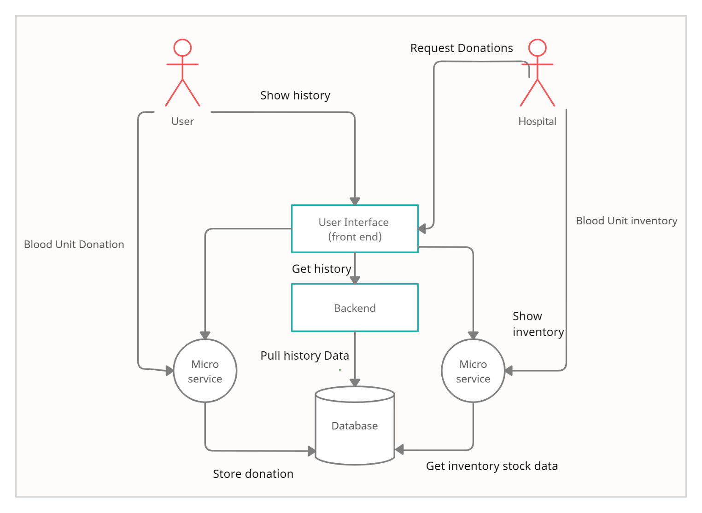

Figure 5.1: Architecture Design

**5.2 Graphical User Interface Design:**

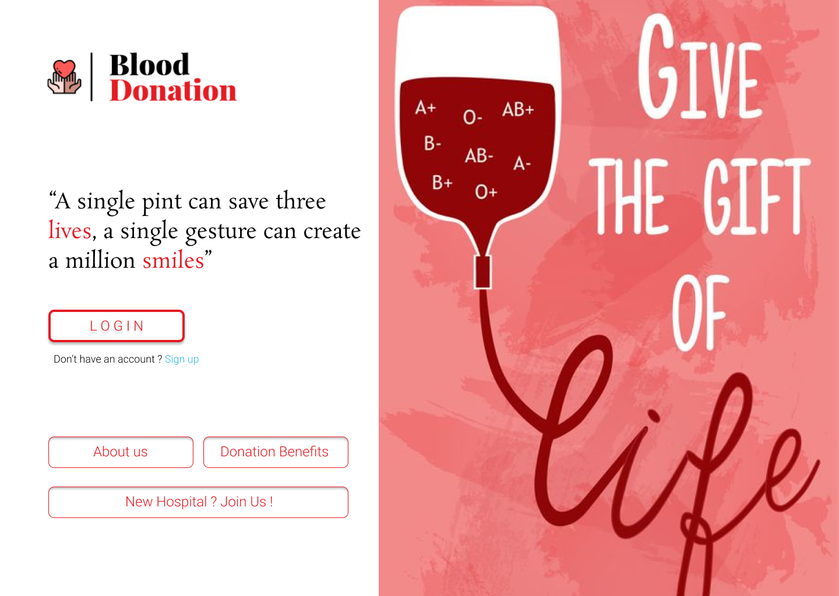

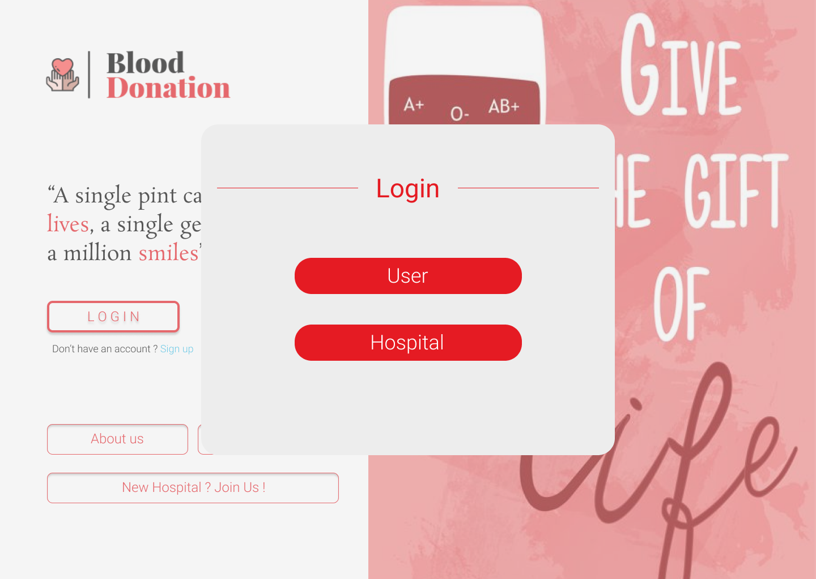

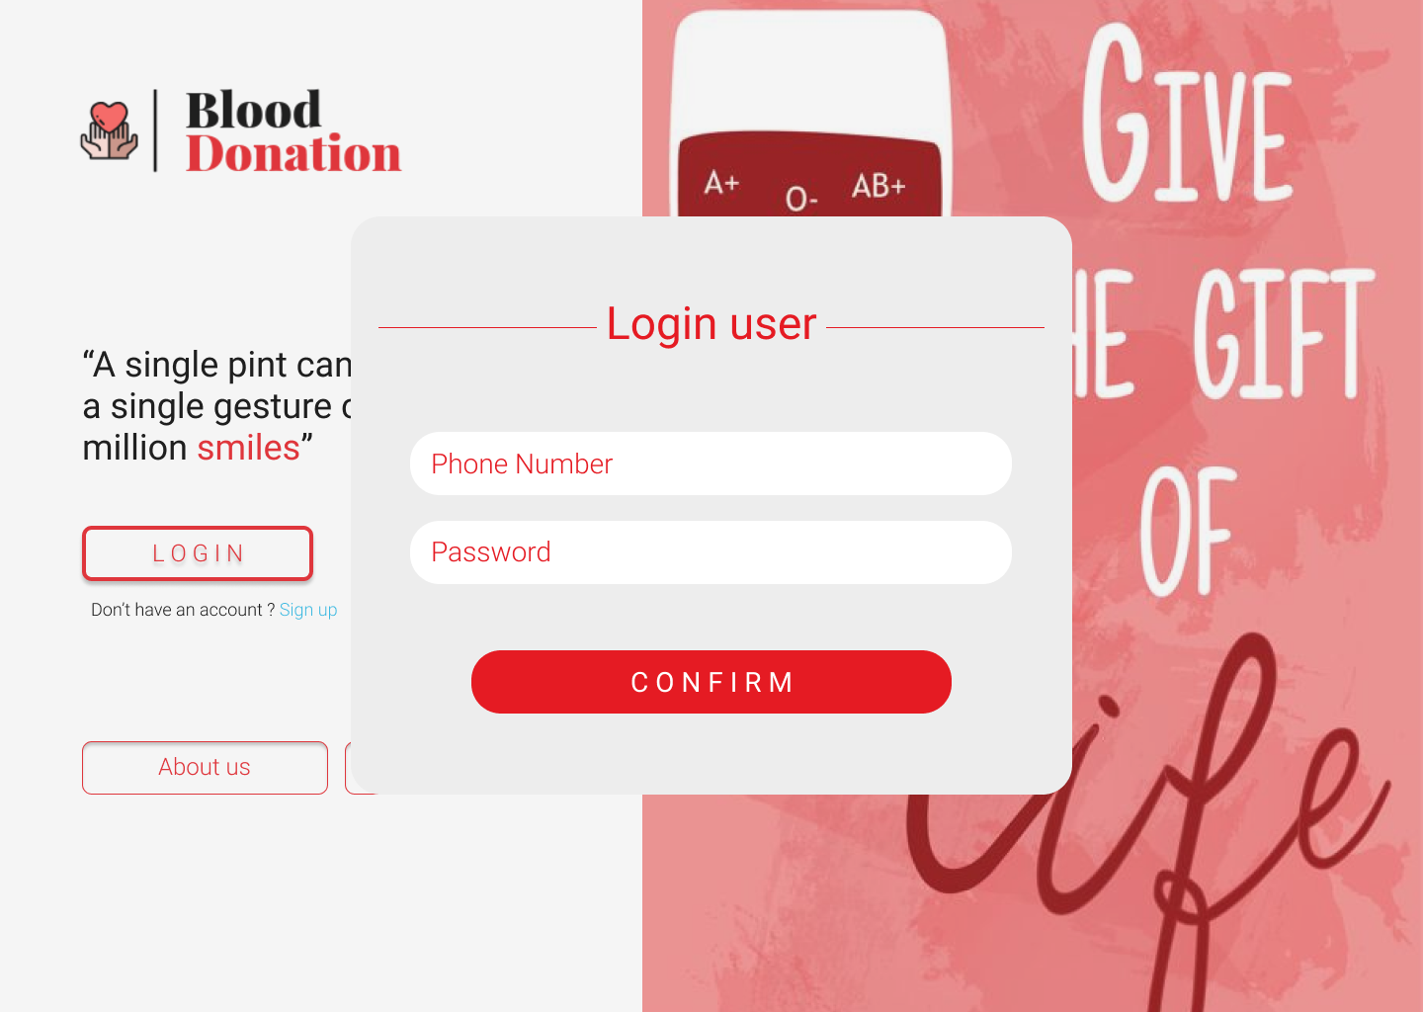

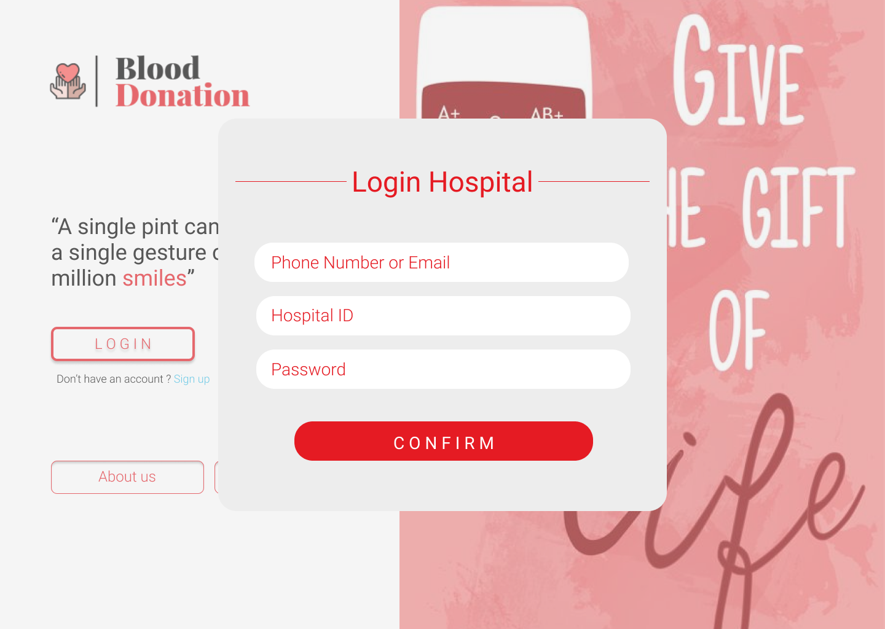

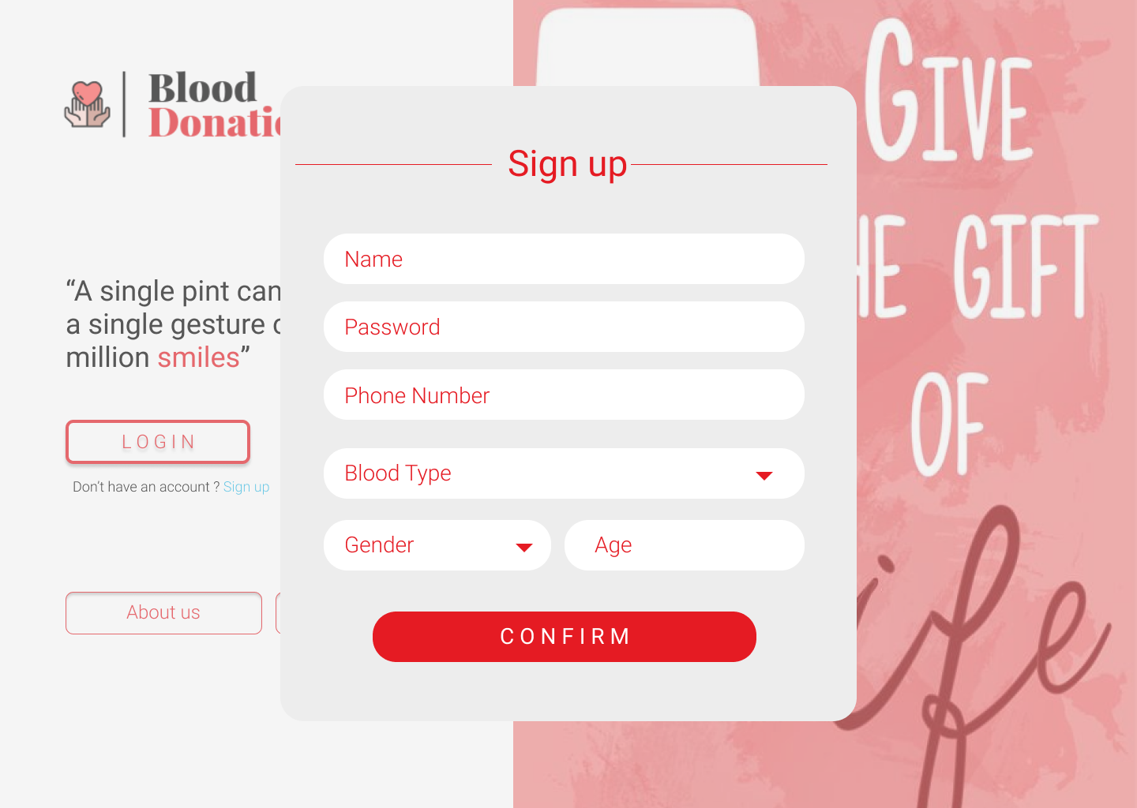

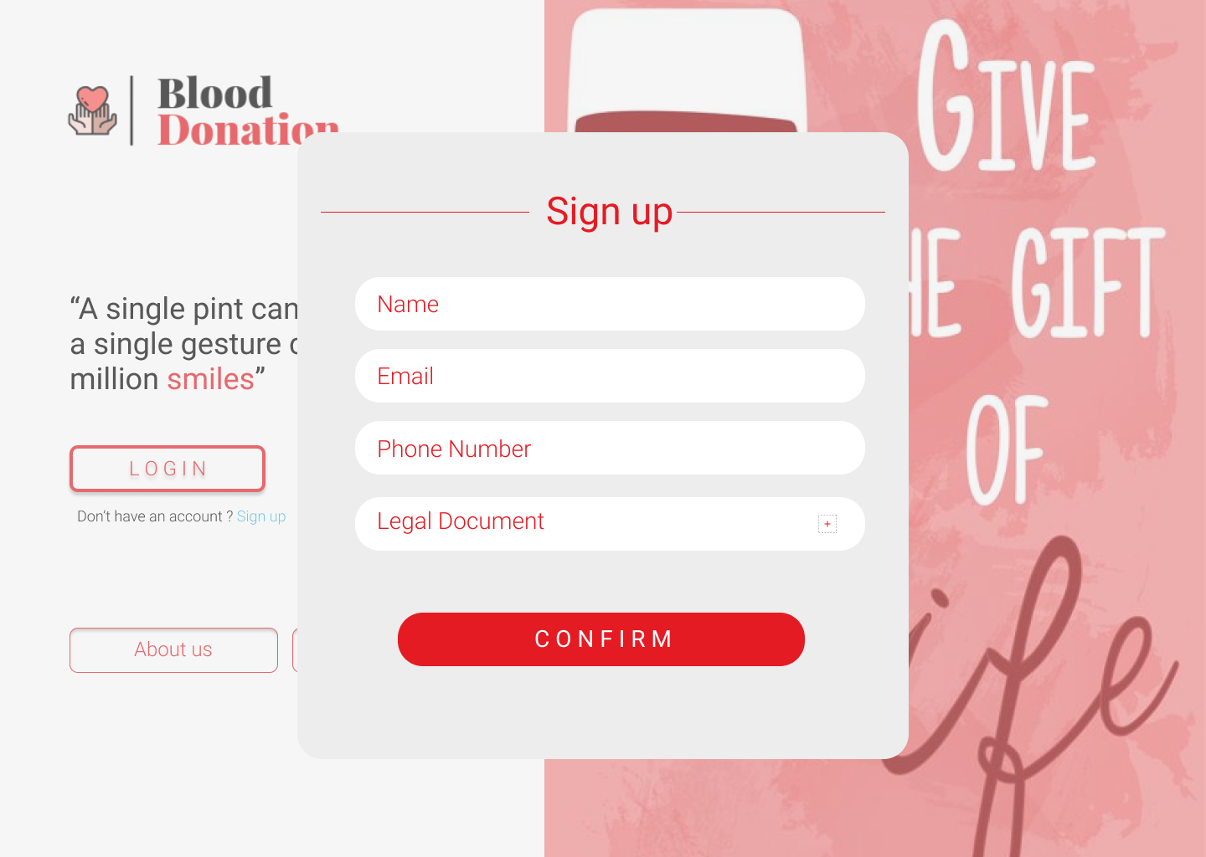

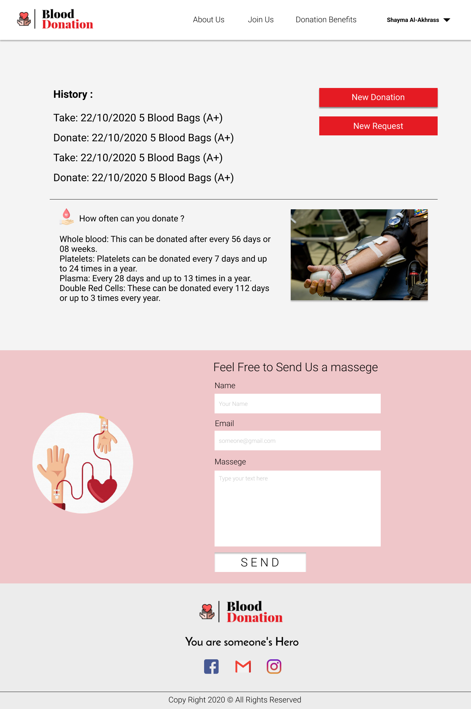

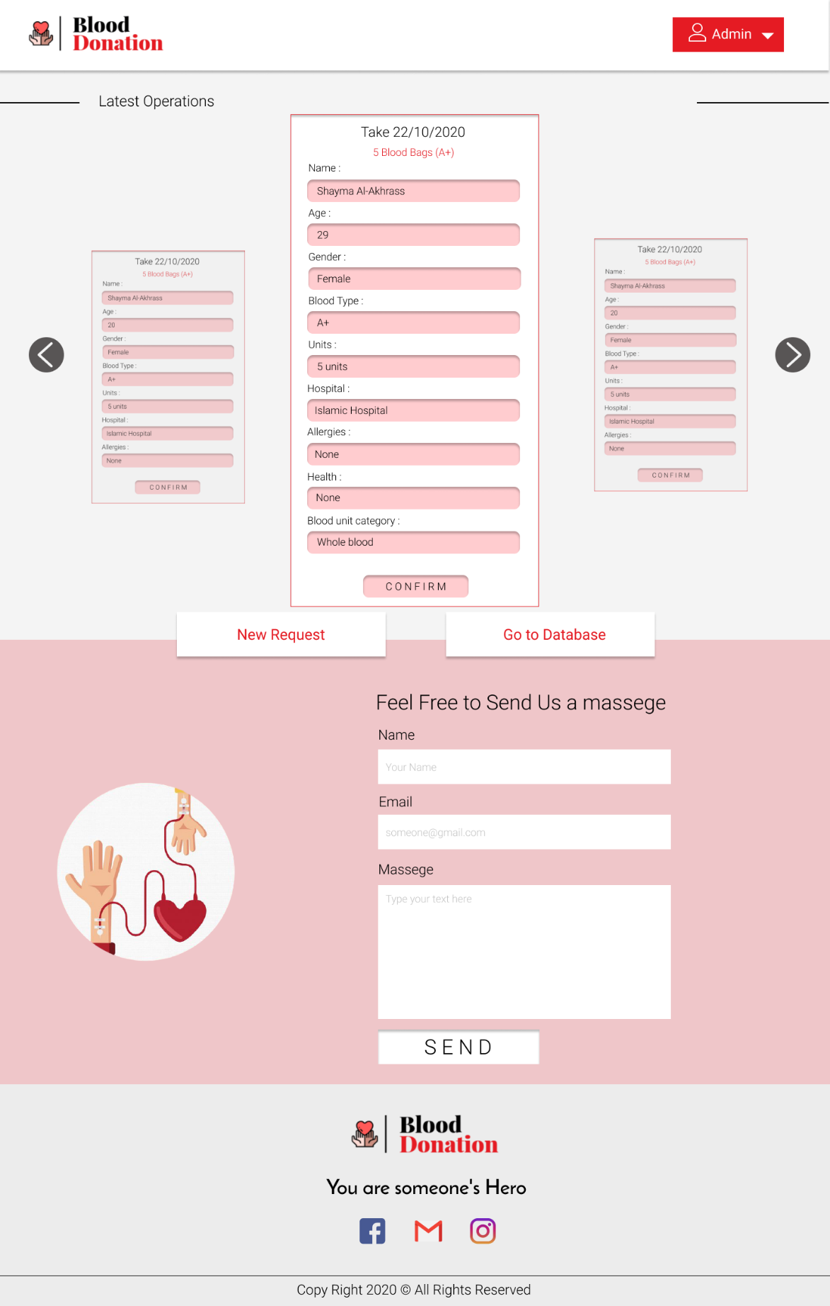

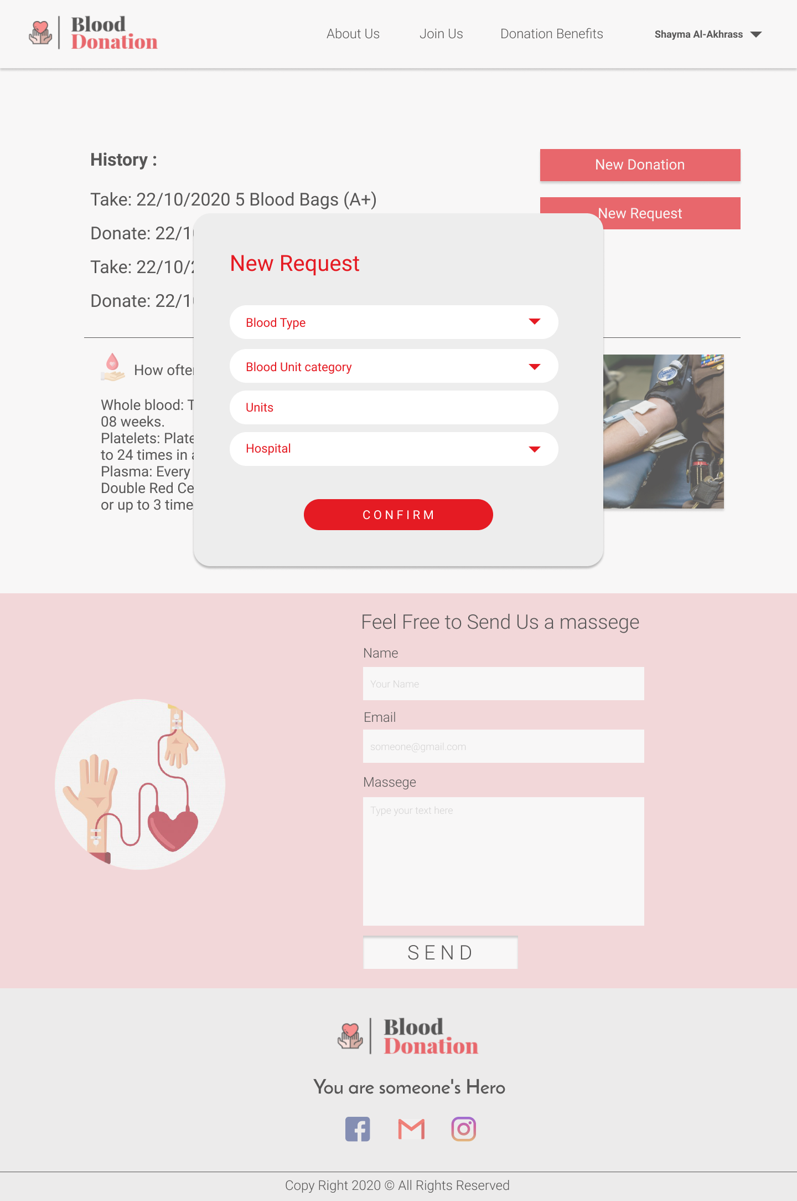

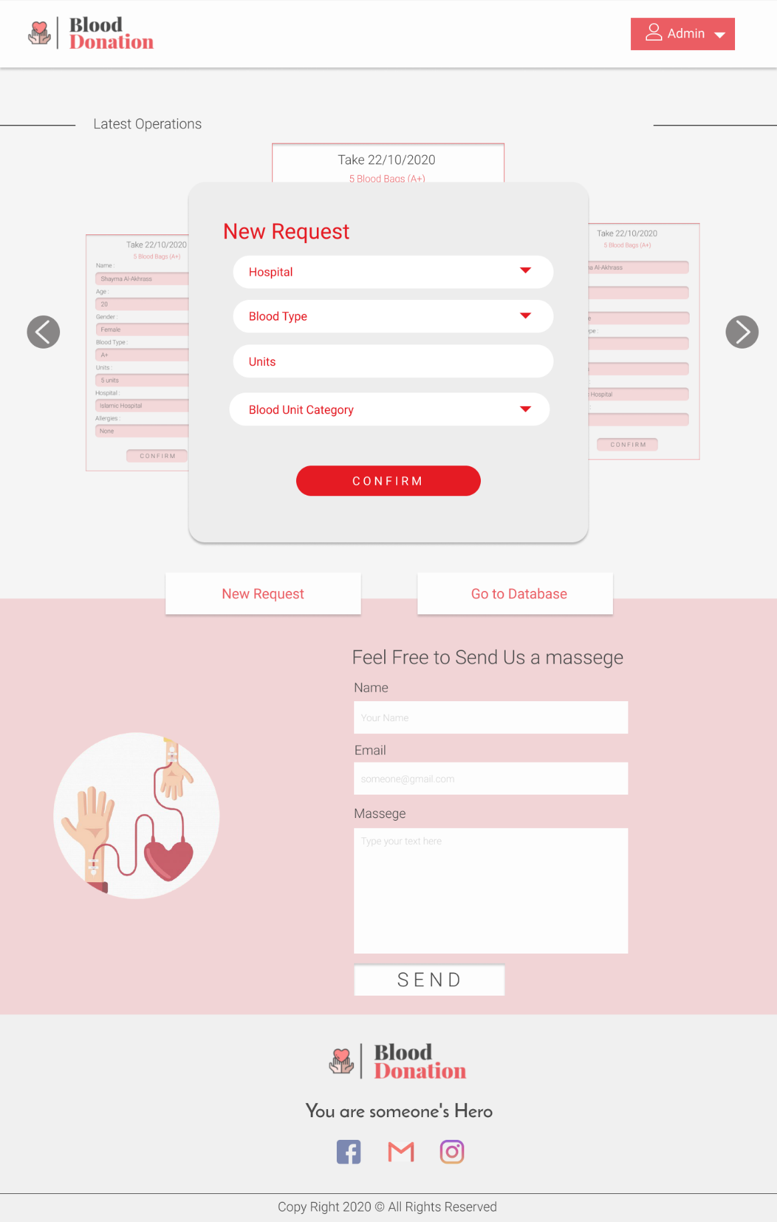

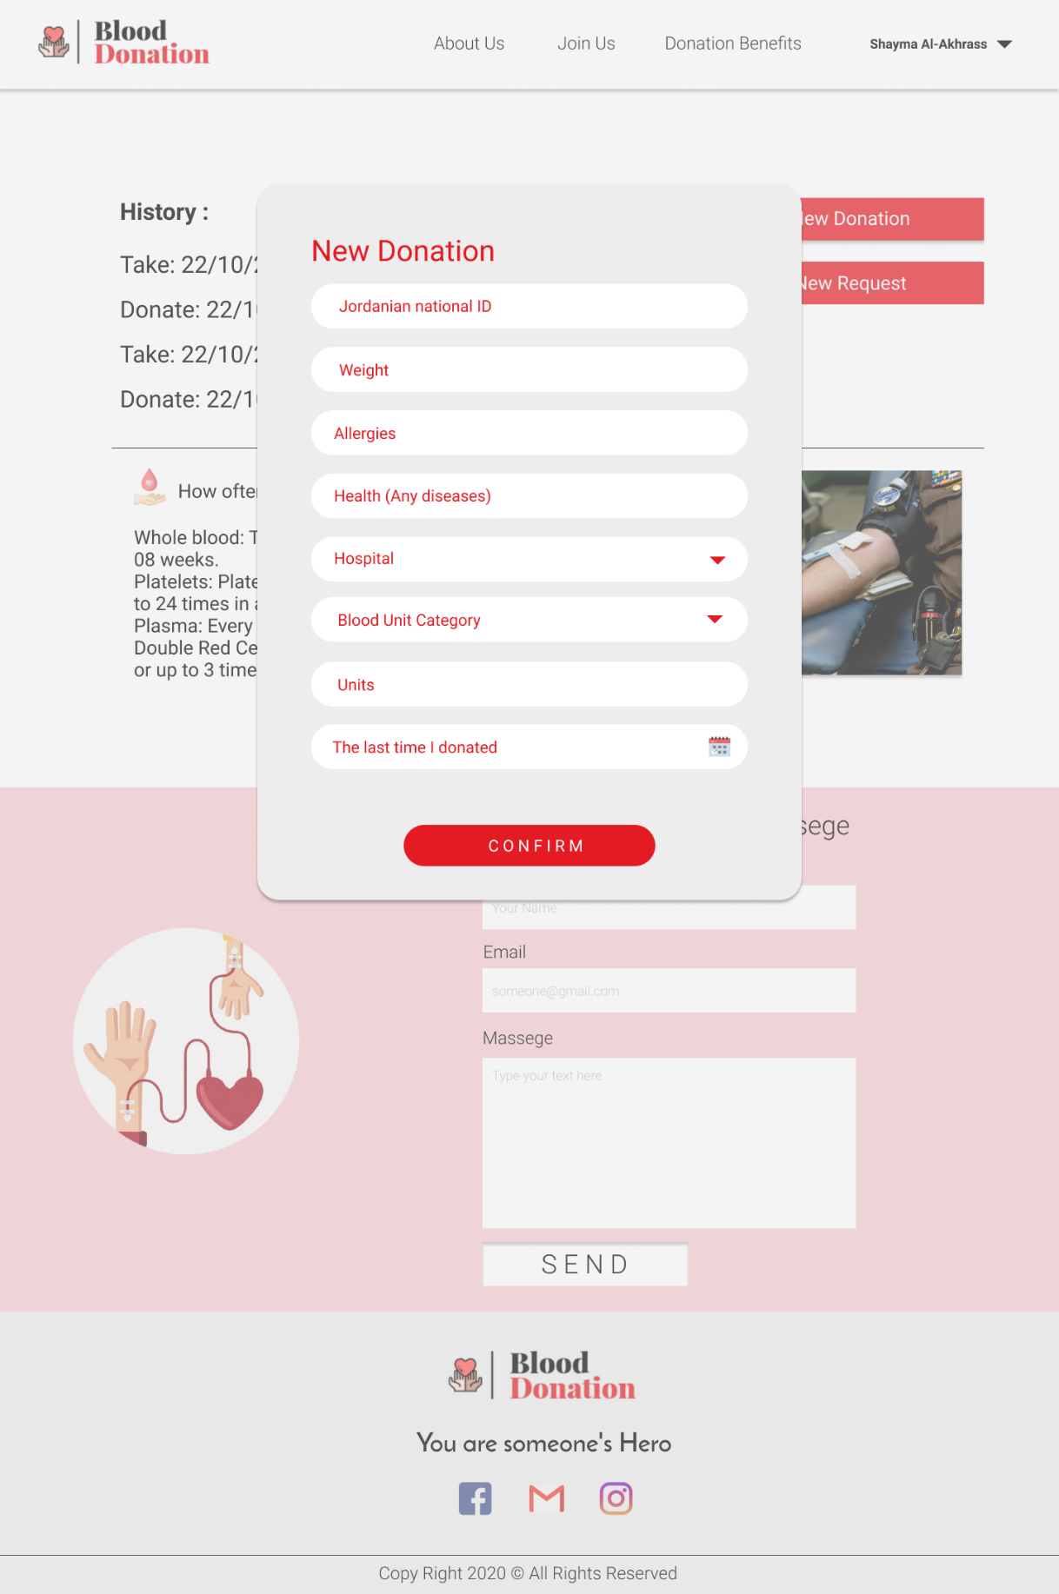

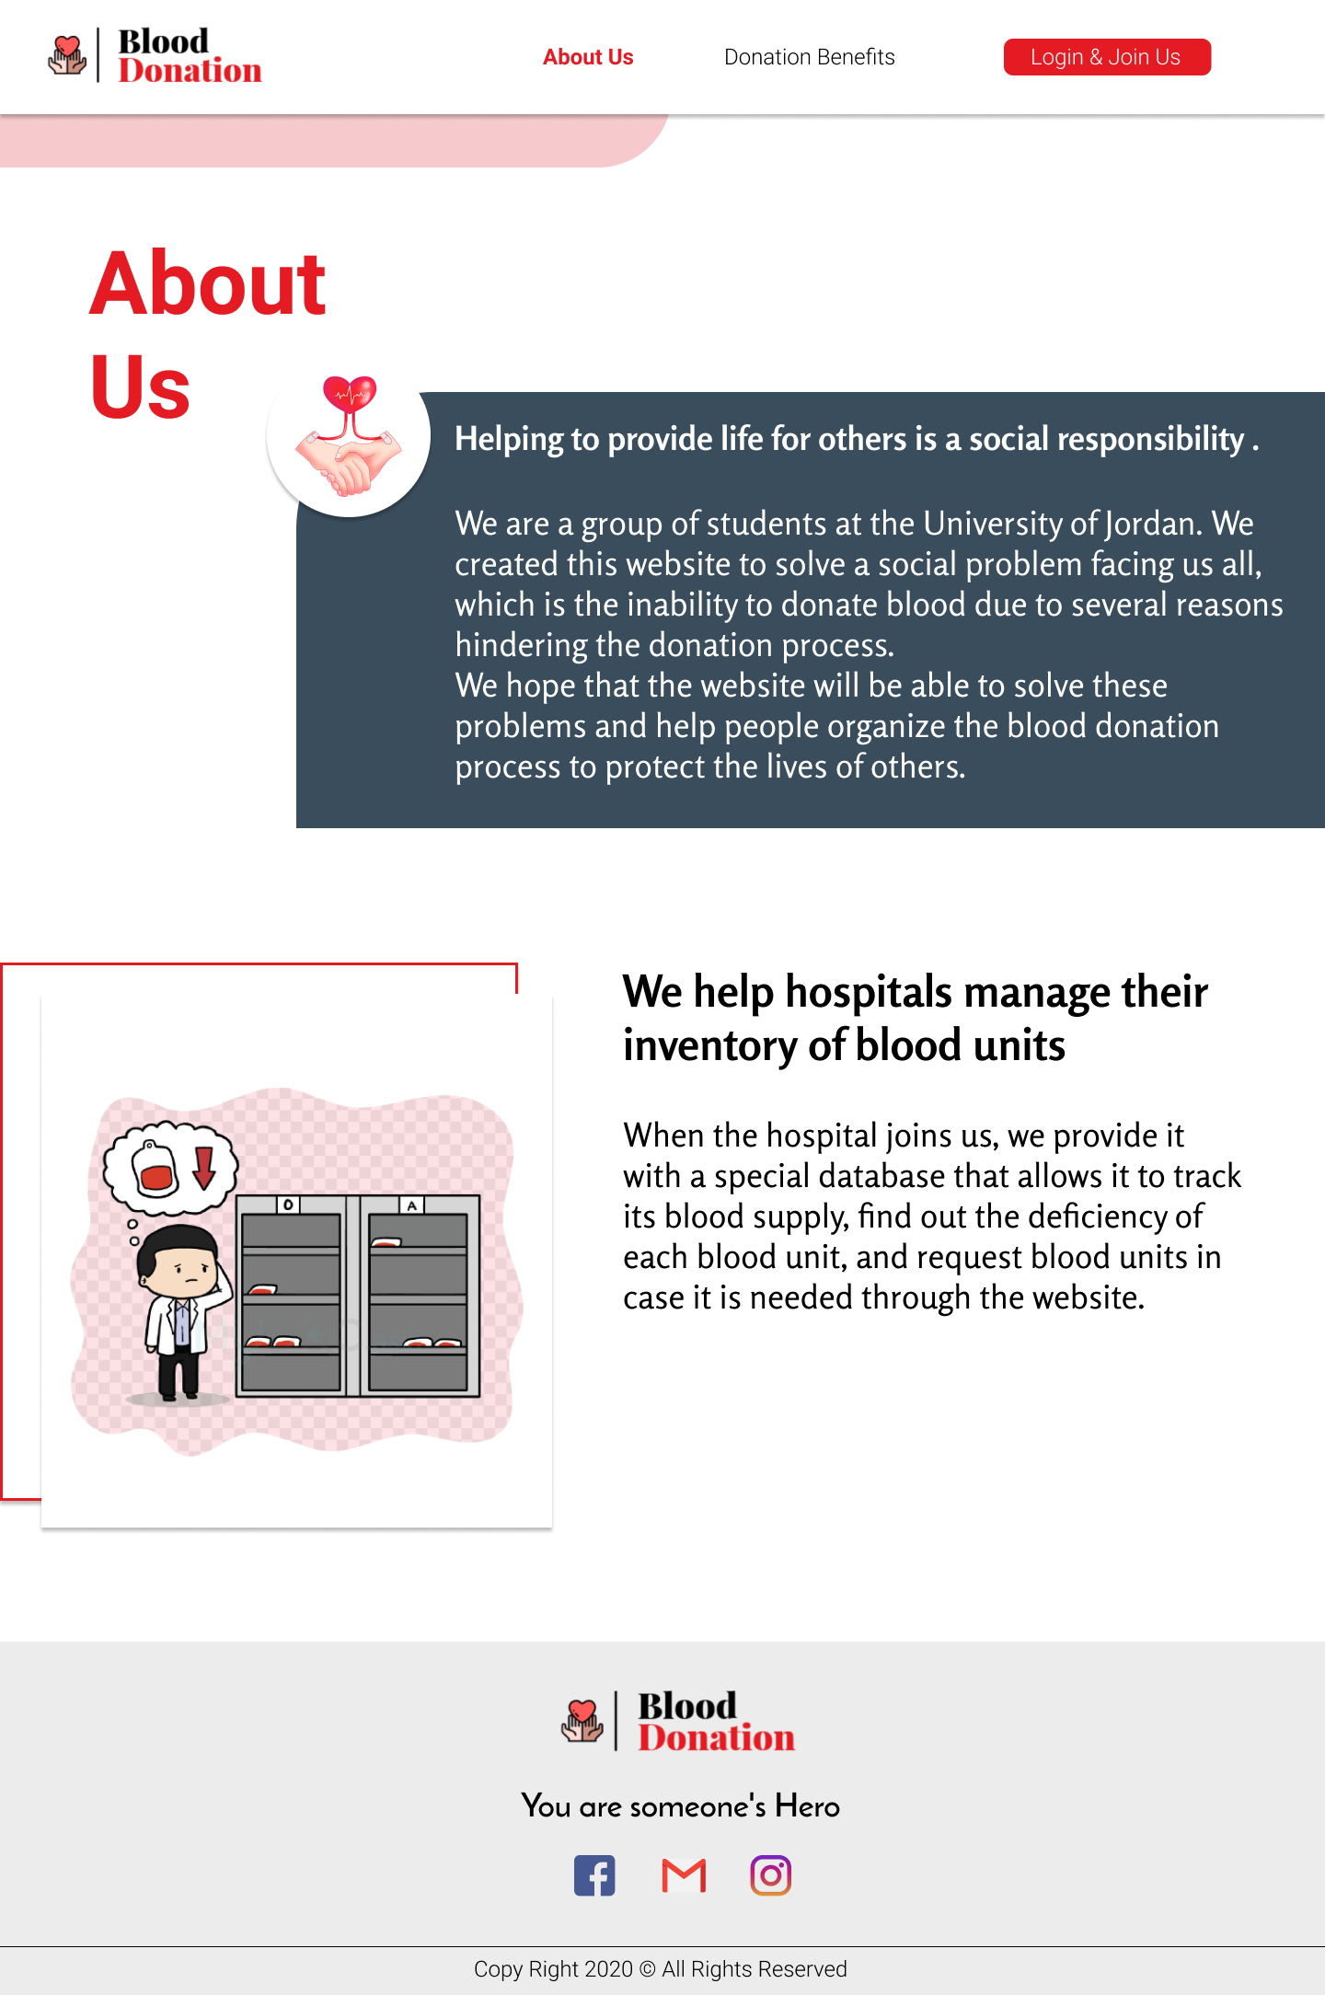

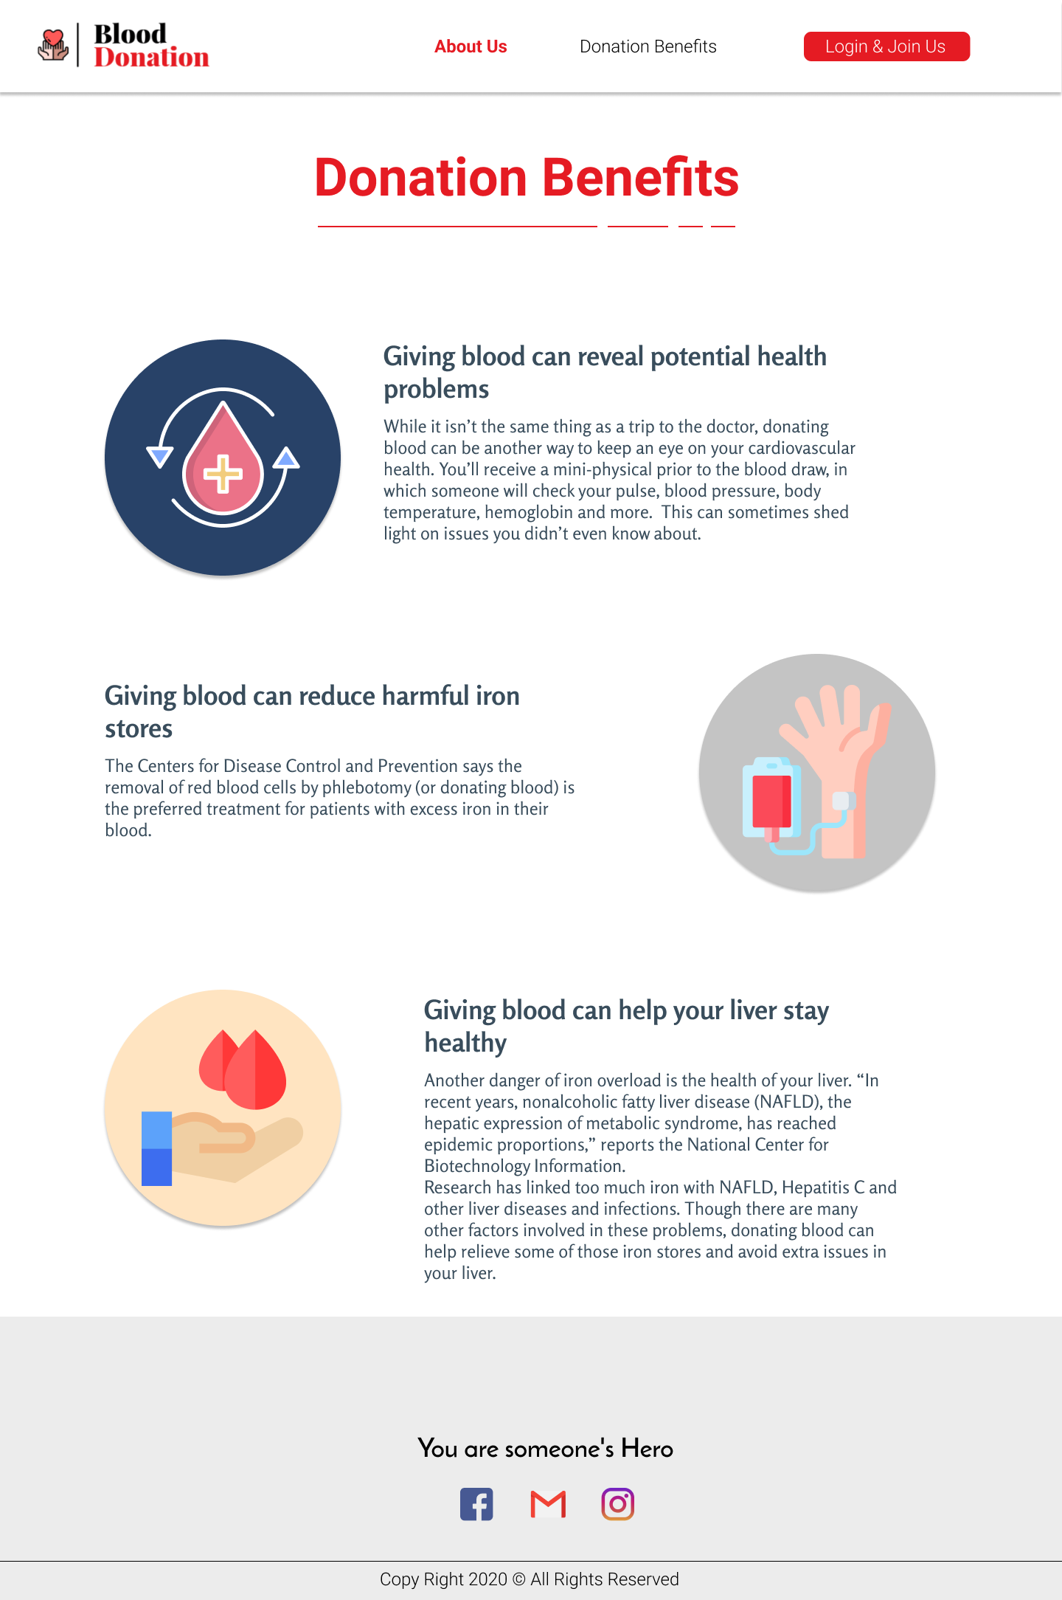

**5.3 Database Design**

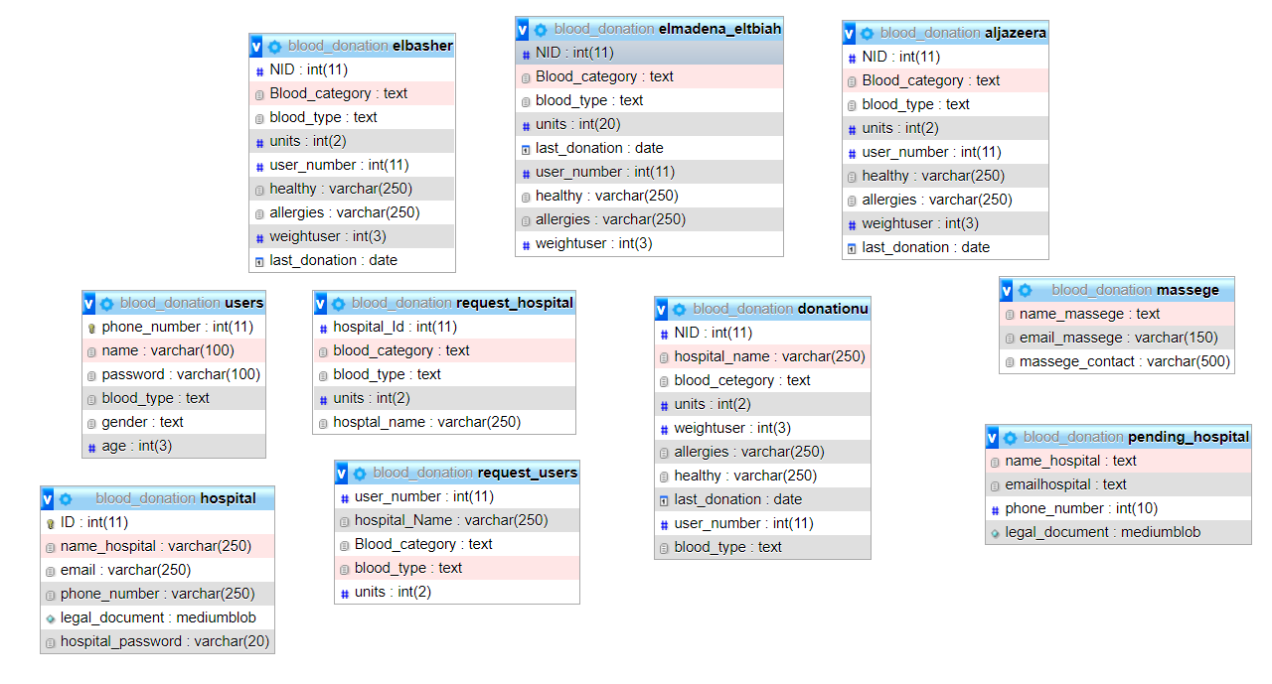

Figure 5.2: database Design

1. **System Implementation**

**6.1 Graphical User Interface Implementation:**

Follow these steps to create an account on our website:

1. This is the first page when you open our website.

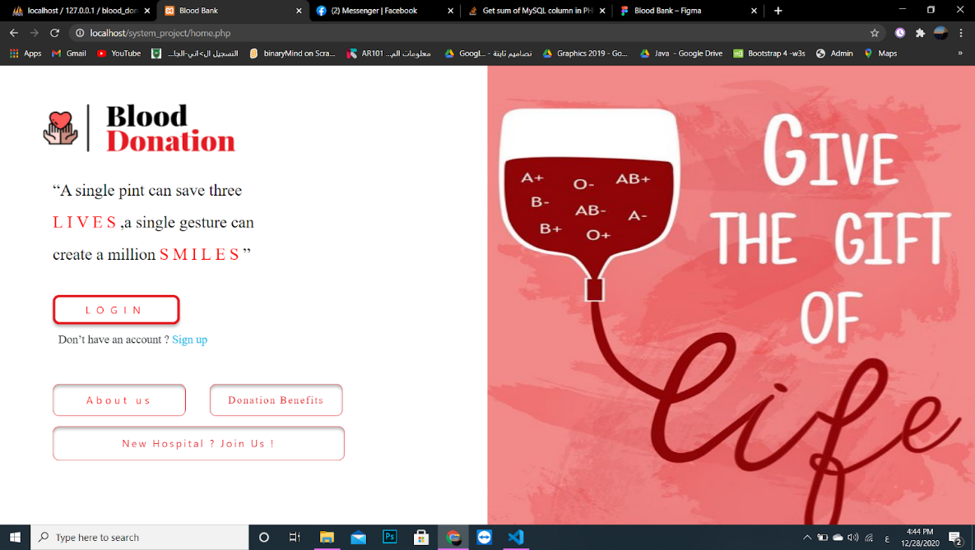

2. If you do not have an account follow these steps:

1- If you are a user and you want to make an account click on sign up.

  You will be required to enter your name, password, phone number, blood type, age, and gender.

Click on confirm.

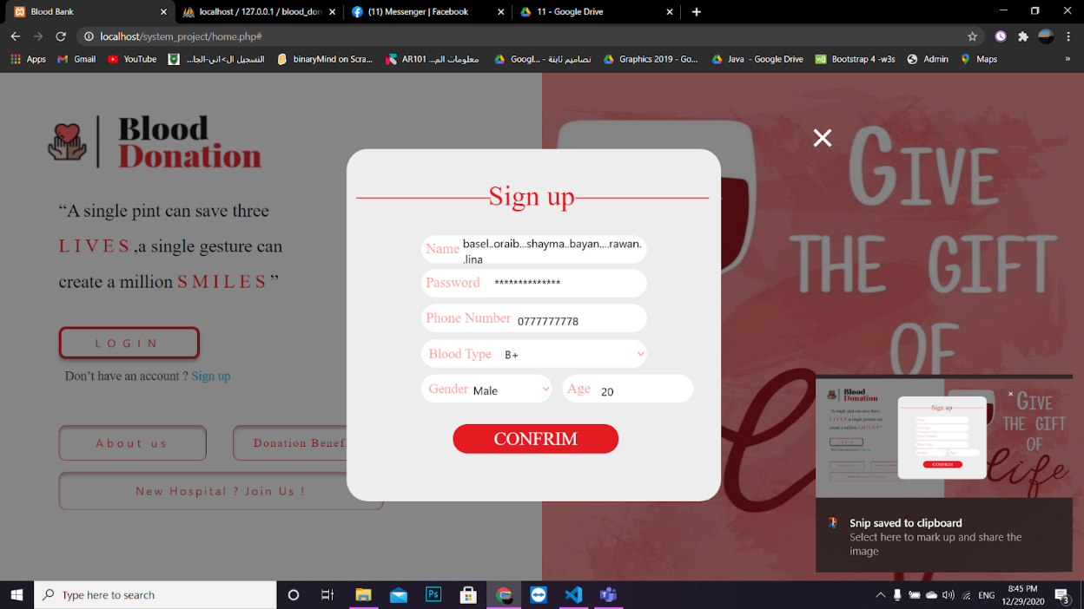

2-If you are a hospital and you want to make an account click on New Hospital? Join Us!

You will be required to enter your hospital name, email, phone number, and legal document.

Click on confirm.

See picture 3:

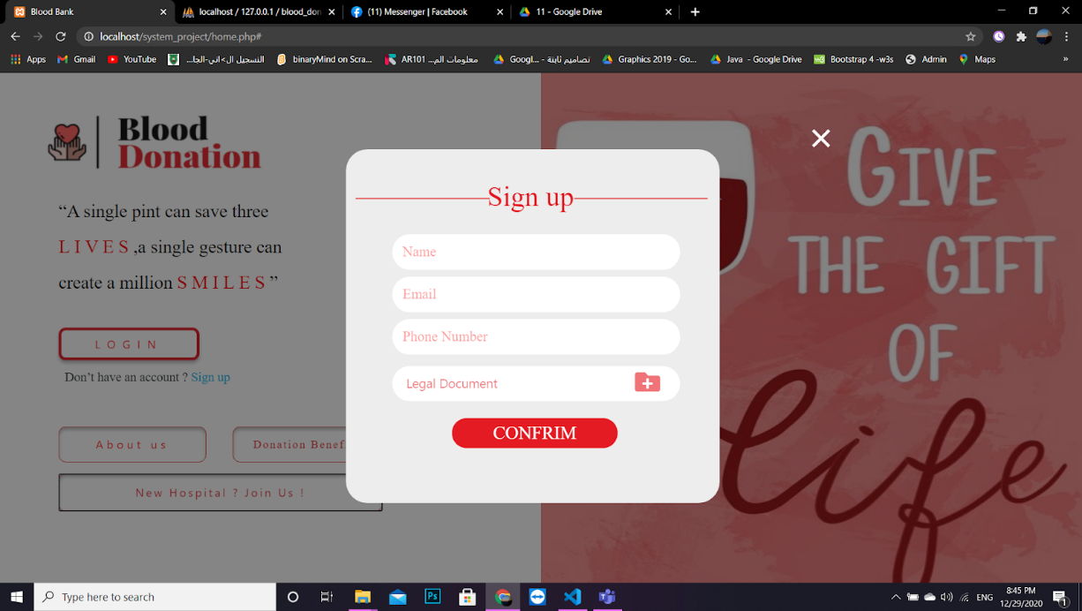

1. If you have an account and you are a user not a hospital clicks on LOGIN.

Choose the first option User.

See picture 4:

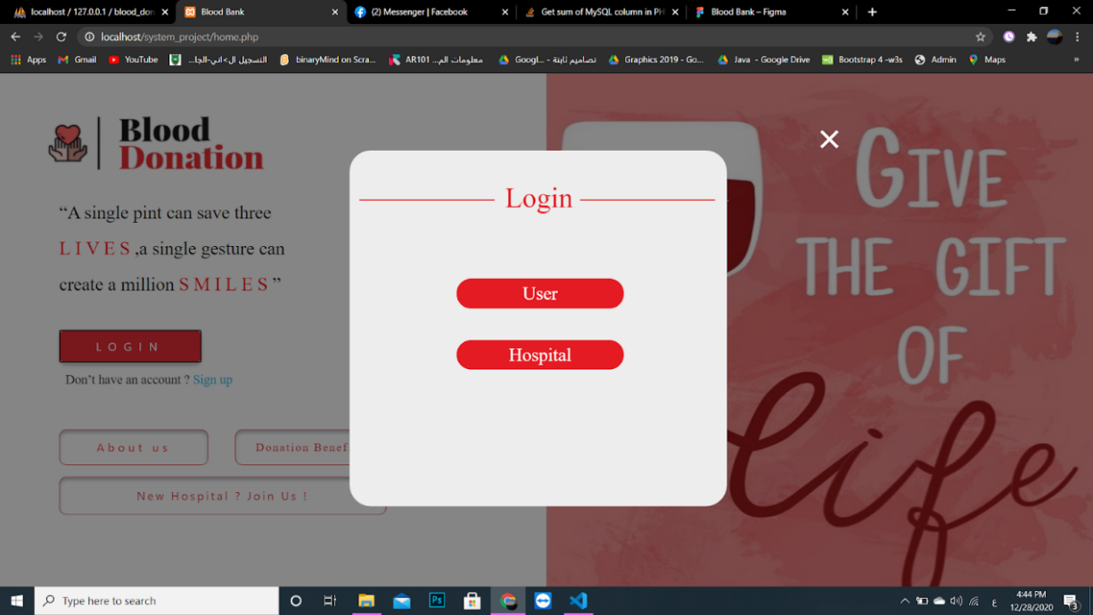

Enter your phone number and password then click on confirm.

See picture 5:

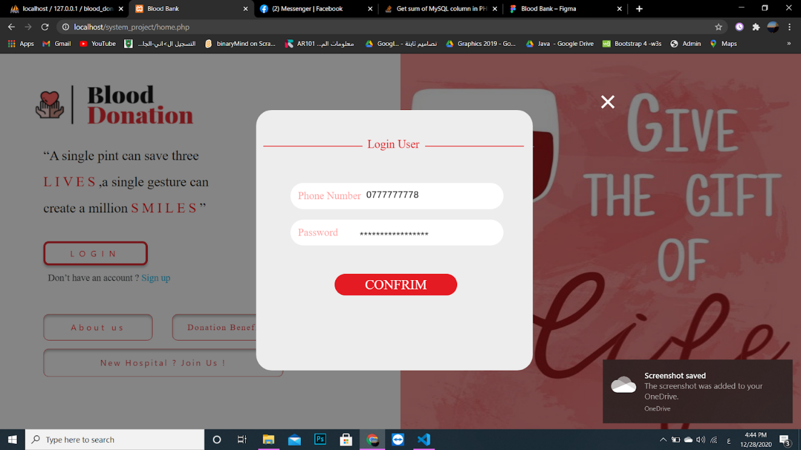

1. If you have an account and you are a hospital not a user clicks on LOGIN.

Choose the second option Hospital.

See picture 6:

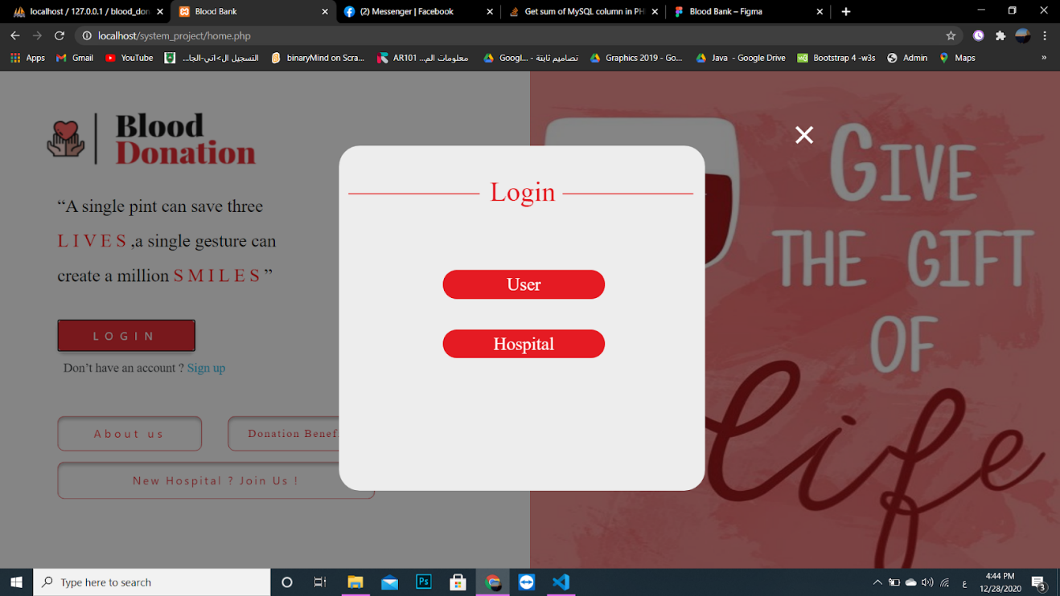

Enter the username, hospital ID, and password.

See picture 7:

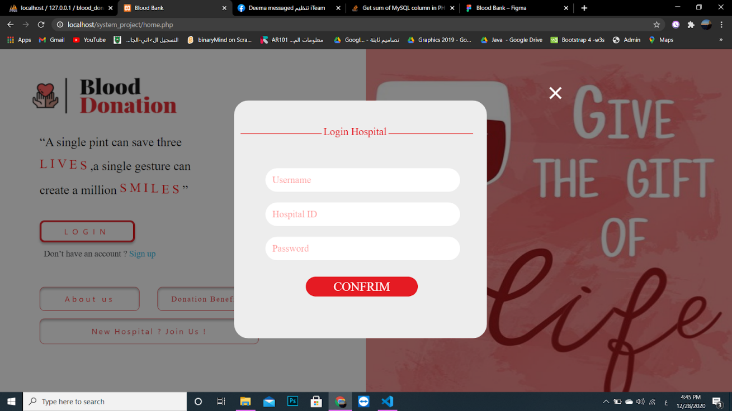

1. Inside your account as a user you can see your history for your donated blood and how often can you donate.

see pictures 8&9:

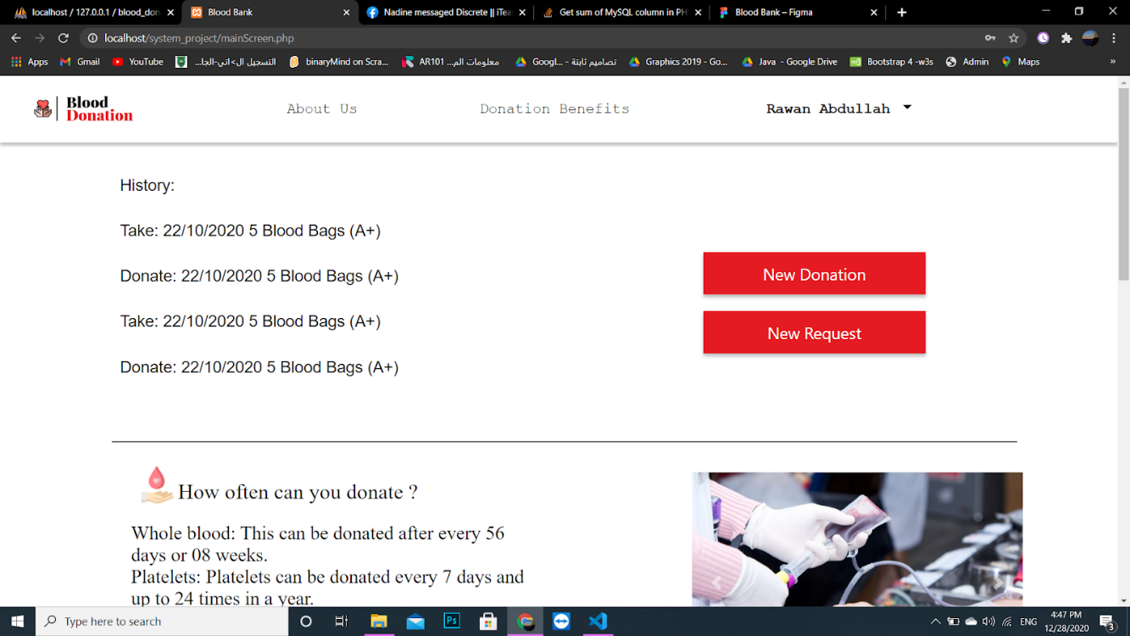

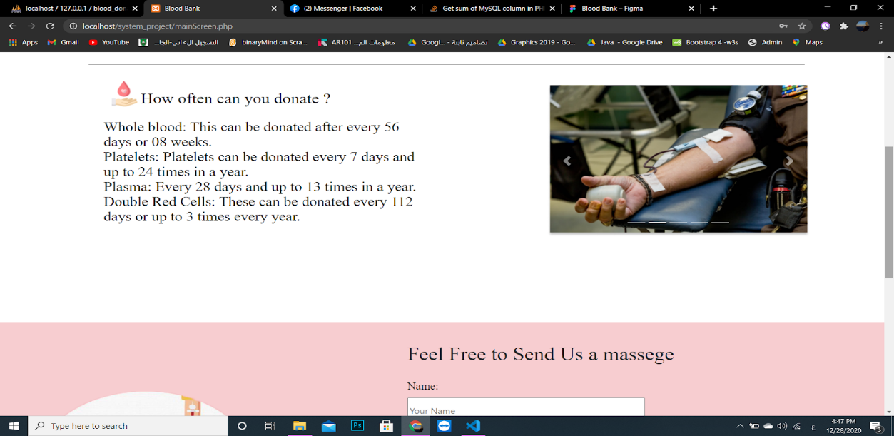

1. If you want to make a new donation click on New Donation.

see picture 10:

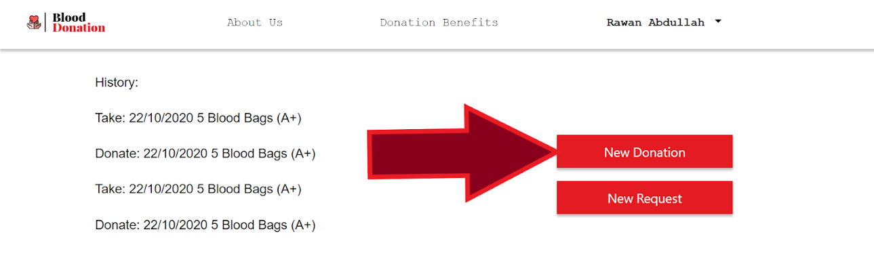

1. Enter your ID, weight, allergies, healthy (infectious diseases), hospital, blood unit’s category, units, and the last time you donate.

See picture 11:

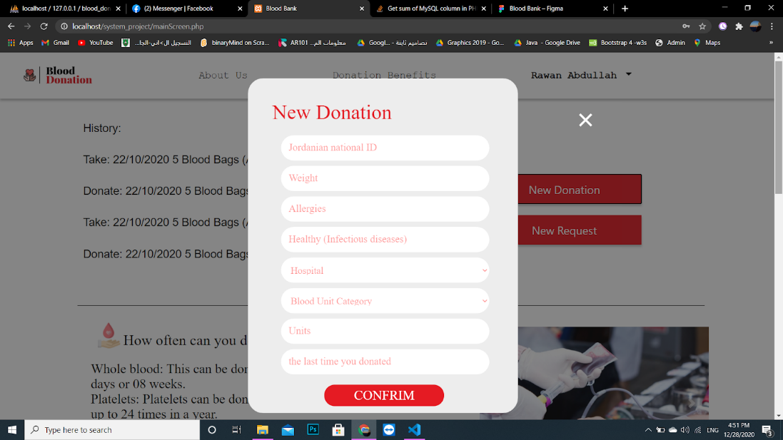

1. If you want to make a request click on New Request.

see picture 12:

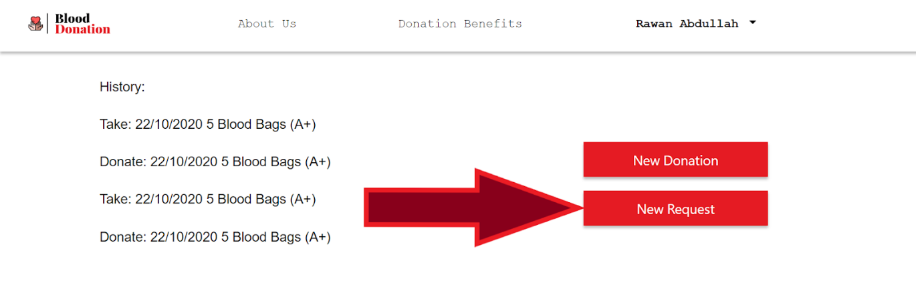

1. Enter the blood type, units, hospital, blood unit category.

See picture 13:

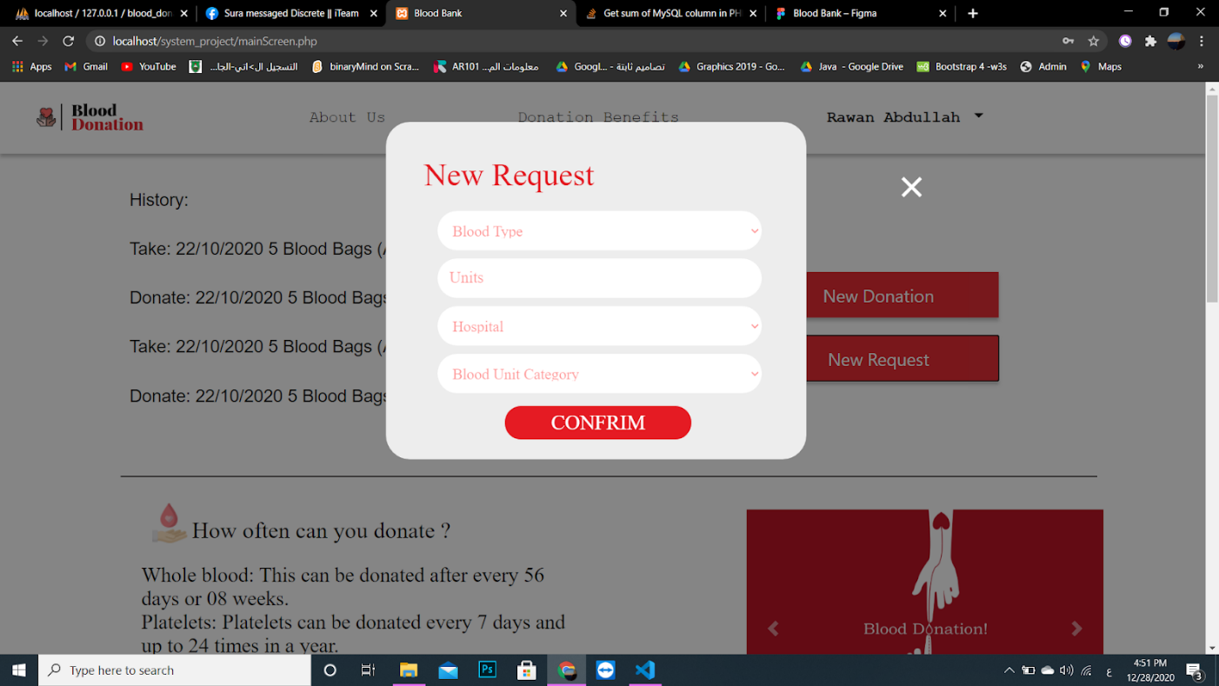

1. Inside your account as a hospital, you can see the last operations for blood donations.

See picture 14:

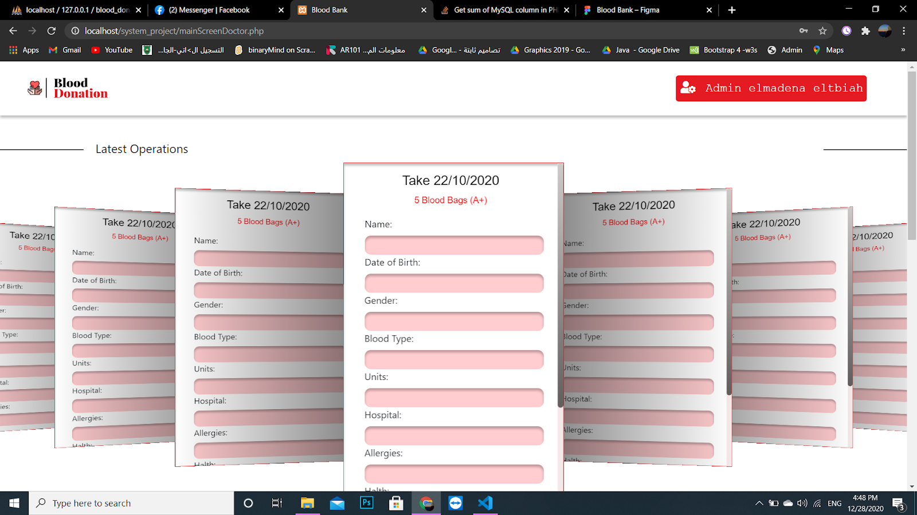

1. If you want to make a request click on New Request. see the figure 16:

See picture 15:

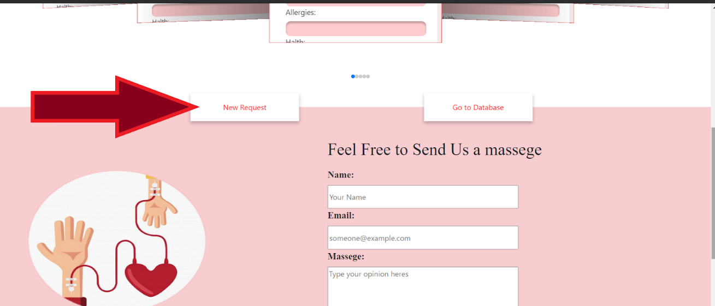

1. Enter the hospital, blood type, units, blood unit category.

See picture 16:

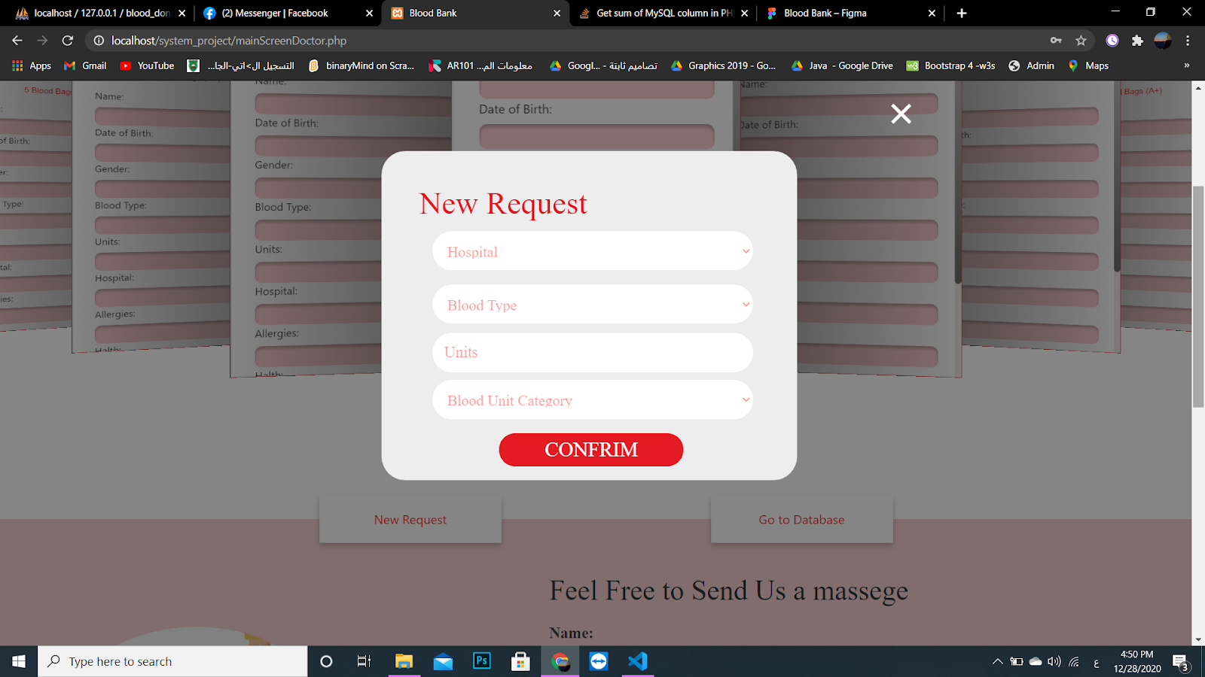

1. If you want to send a message for us go to the bottom of the page write your name, email,

and your message. click on SEND.

see picture 17:

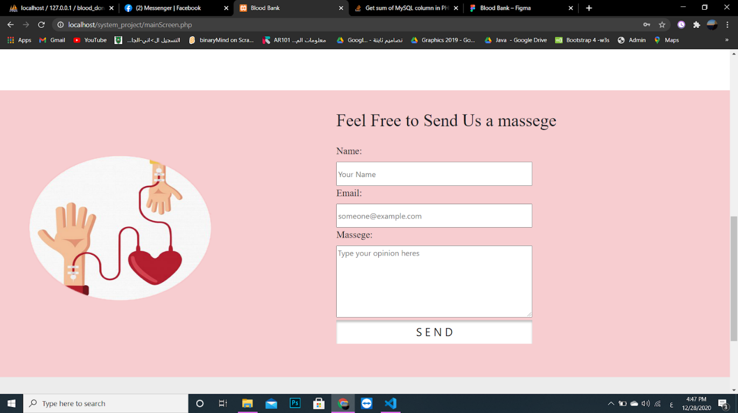

1. If you want to know more information about us please Click on About Us.

see picture18:

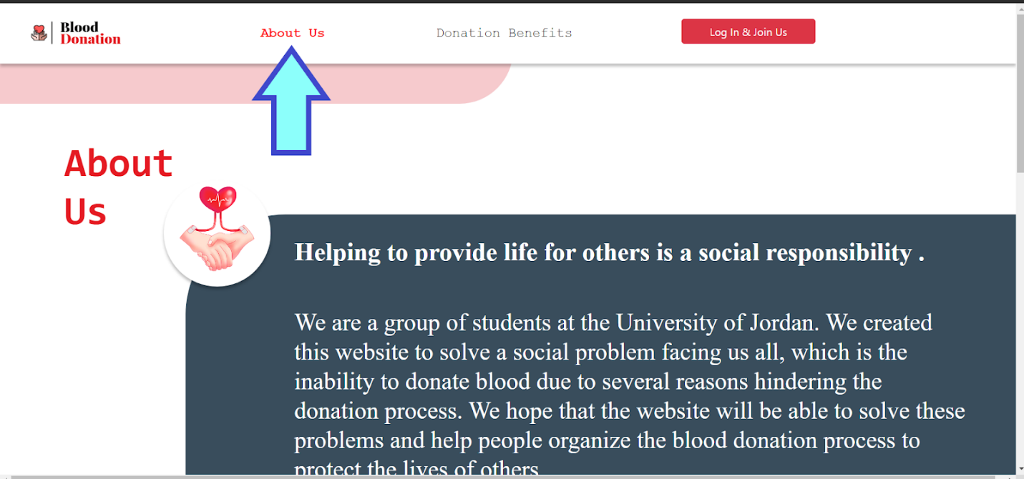

1. If you want to know more information about donation benefits please Click on Donation Benefits.

see picture 19:

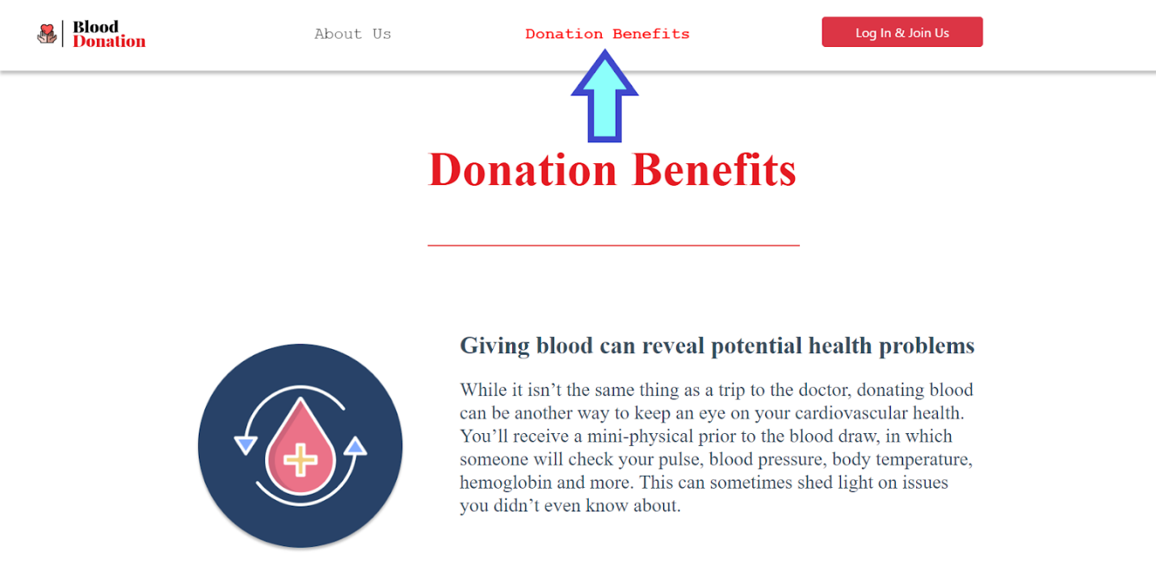

**6.2 Database Implementation:**

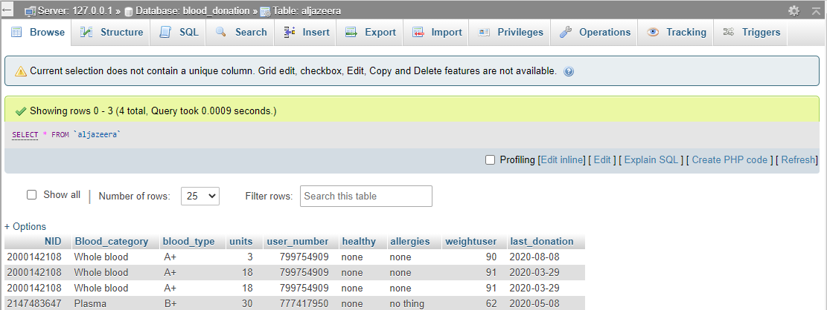

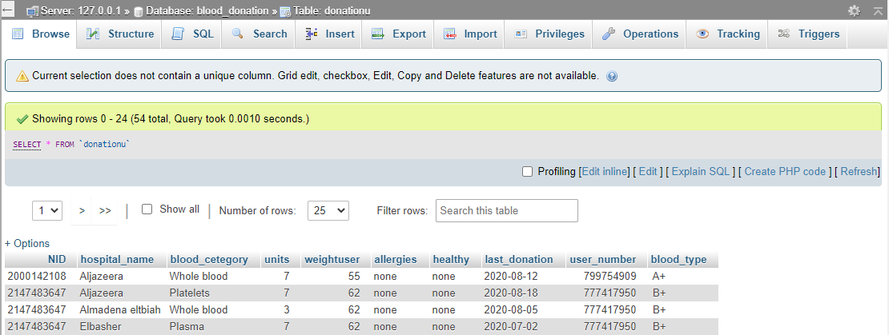

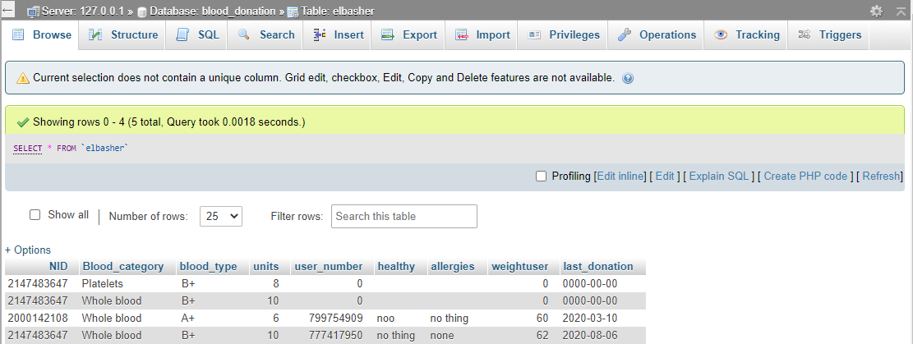

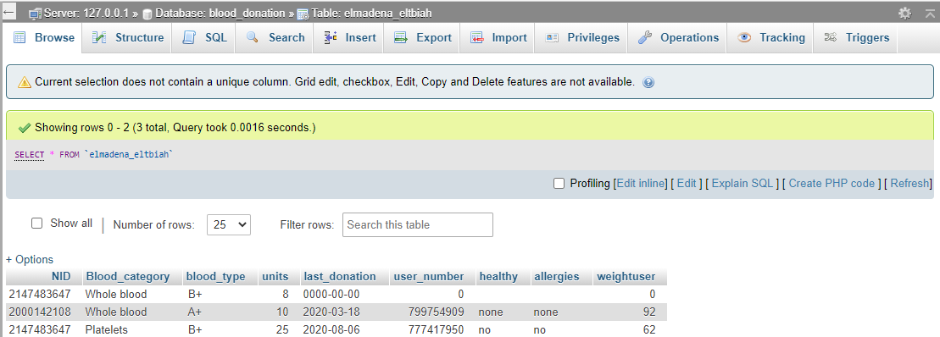

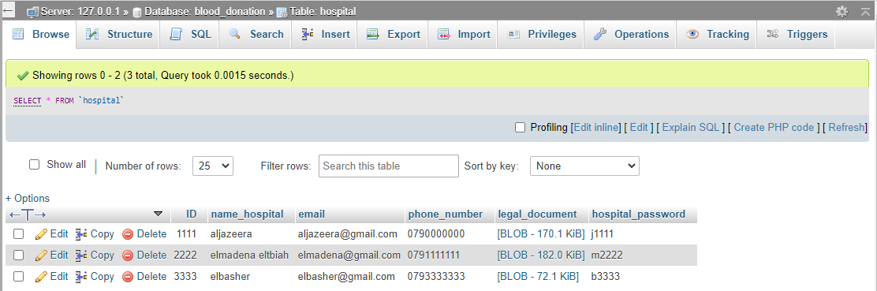

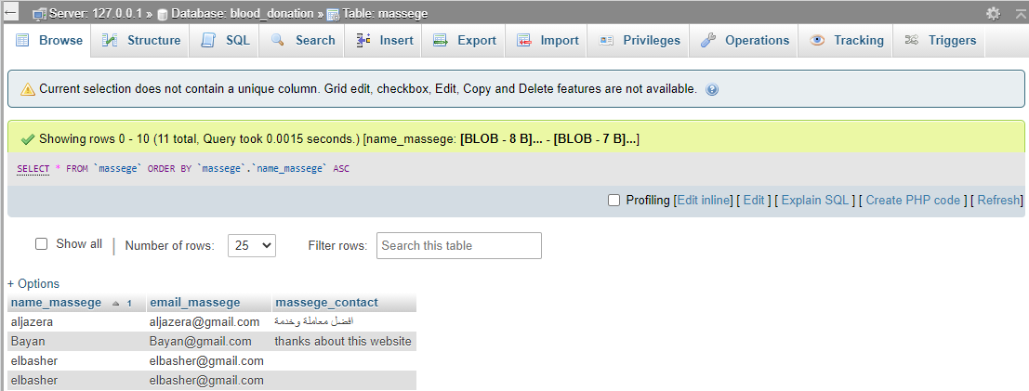

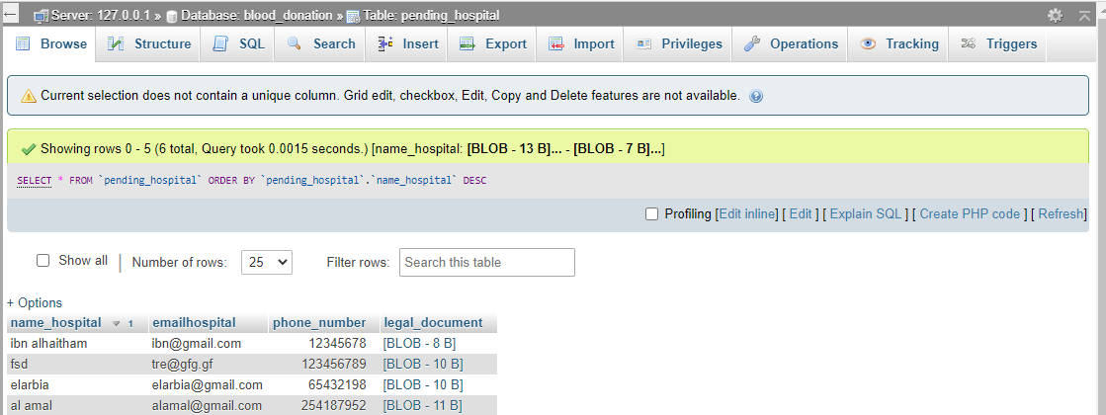

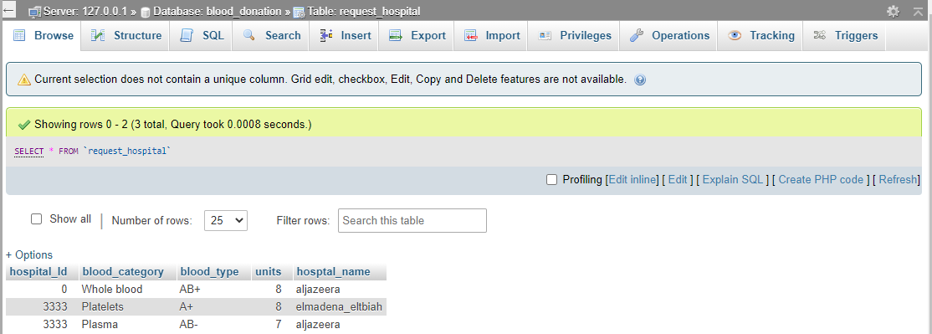

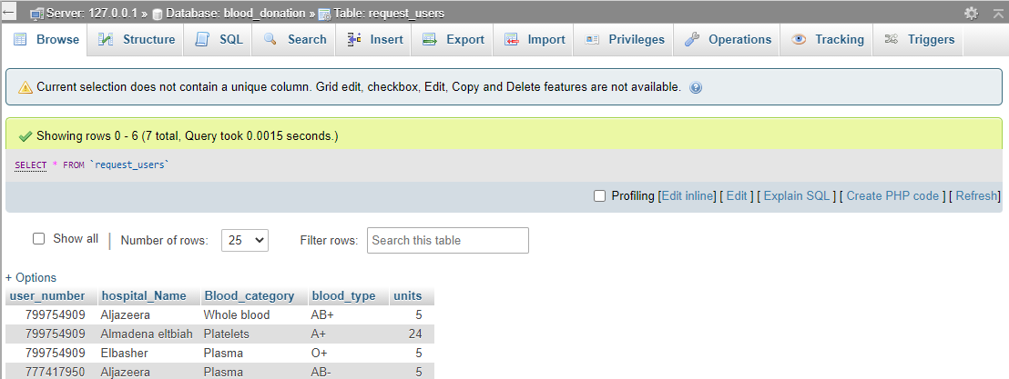

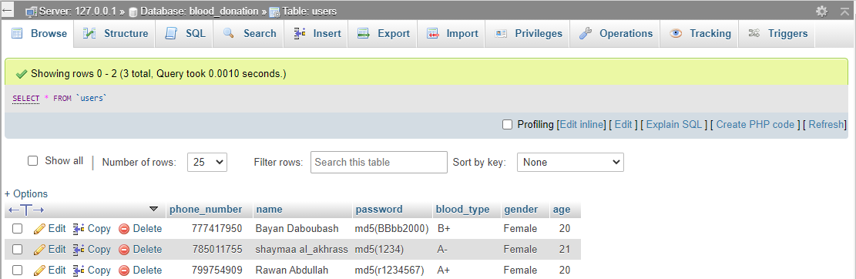

**7- Conclusion**

We expect from our system to achieve the main goals to reduce the time, effort, risk, and complexity of blood donations.

We believe that this system can be easily applied to many real-world hospitals and can benefit them greatly. As it also can benefit the donators.

The system can be improved in the future by the creation of a mobile app, which both hospital employee and donators can use. Multi-Language support can also be added to further enhance the experience.

**8- References**

- draw at <https://app.creately.com/diagram/aS5mdfjn84e/edit>

- how to make an architecture design article from: <https://medium.com/>

- wireframing at <https://www.figma.com/>

- we draw the ERD at <https://app.diagrams.net/>

1. **Appendix**

**Project code:** <https://drive.google.com/file/d/1LufcgcYtkCY0DDwpORP5kYEaa26f2Wq1/view?fbclid=IwAR0j4DBo3b1_LuvCkbKraEtbuF_QM3vsw6mvWt5SMtr5lMByto56opwZluI>

**Explanatory video:** <https://drive.google.com/file/d/1s990O980meIkQxe26mrC7C0yYJpQoxxC/view?usp=sharing>